Employee System Database  
 Final Report

CPSC-488 Spring 2023

03/31/2023

Paul Schlabach pms1006@sru.edu

Bradon Walters bdw1006@sru.edu

Maya Smallwood mns1013@sru.edu

**GLOSSARY**

**Problem Explanation 3**

System Overview 3

**System & Hardware Requirements 3**

**Setup & Installation 4**

Installation Manual 4

User Manual 34

**Testing 35**

JUnit Testing 35

**Documentation 35**

Technical Manual 35

Security Manual 70

**Project Completion 73**

Evaluation Manual 73

**References 79**

# 

# 

# **Problem Explanation**

## System Overview

Gazebo HQ is an employee management system designed to make life easier for companies that have recently transitioned to a hybrid or remote working environment. Our vision for Gazebo HQ was to make an all-in-one system that would make the everyday work life of employees easier by managing employee information, such as their personal information, while also providing a tool to keep track of important statistics such as their payroll information and timesheet logging. With our system in its current state, users can register for an account and sign into the system, at which point they will be brought to our dashboard. On the dashboard is a menu button that will list various different options for users to select through a dropdown menu. These options include things like add and manage users, time sheets, payroll, and more. Through the use of Excel files, admins can upload employee information in bulk which will be saved to the system database to be used for processing further information.

# **System & Hardware Requirements**

Operating System: Windows 10 or Newer

CPU: 2 or more Cores

GPU: N/A

Memory: 4GB or more

Software:

* Eclipse Java IDE
* Spring Tools 4 Eclipse Plugin
* MySQL Workbench

# **Setup & Installation**

## Installation Manual

Steps to download and open our Project:

1. First login in and connect to our GitHub repository website

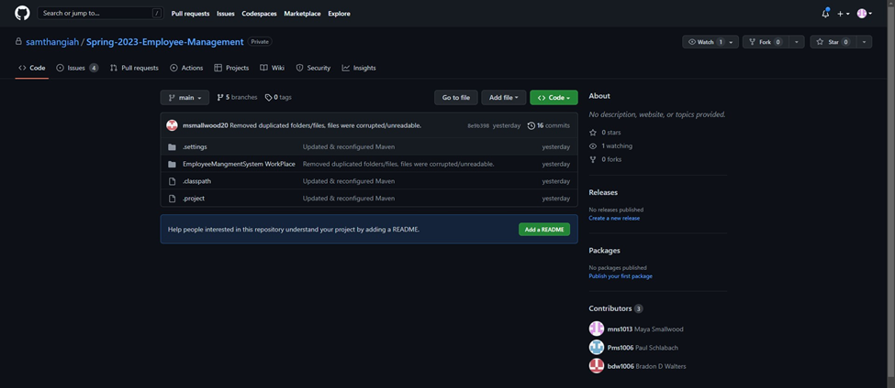

2. Next select Code and Select HTTPS, and then copy

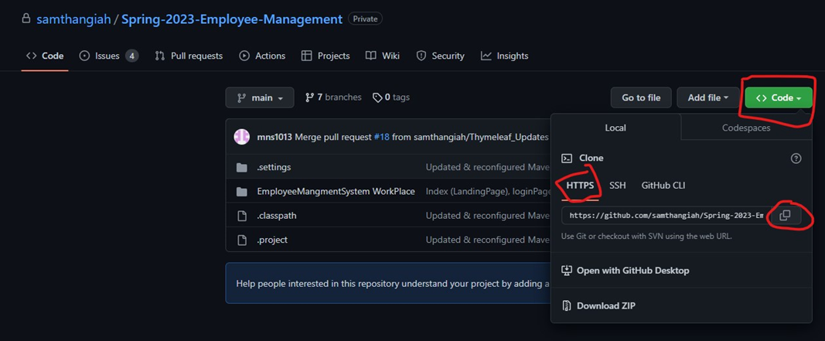

3. Next Open Eclipse IDE Enterprise Java & Web Developers-2022-12 create/select an empty folder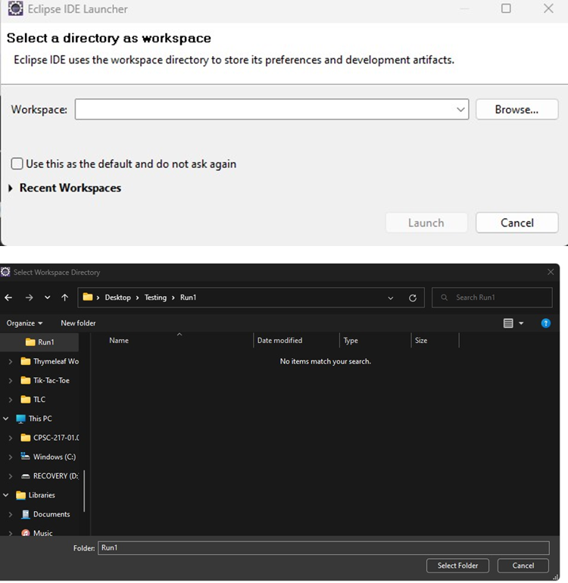

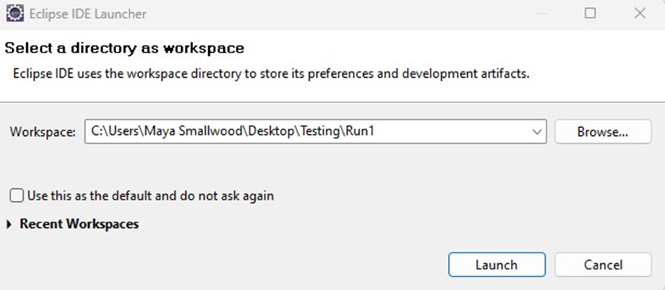

4. Next close the Welcome Window

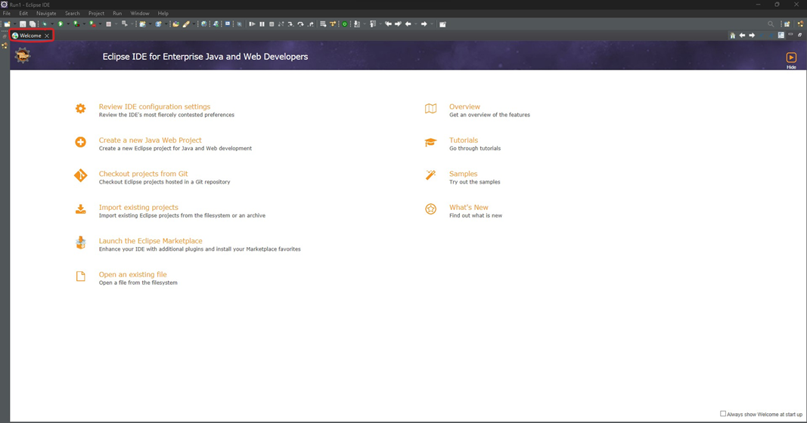

5. Next select import project and then Git, Projects from Git (with smart import)

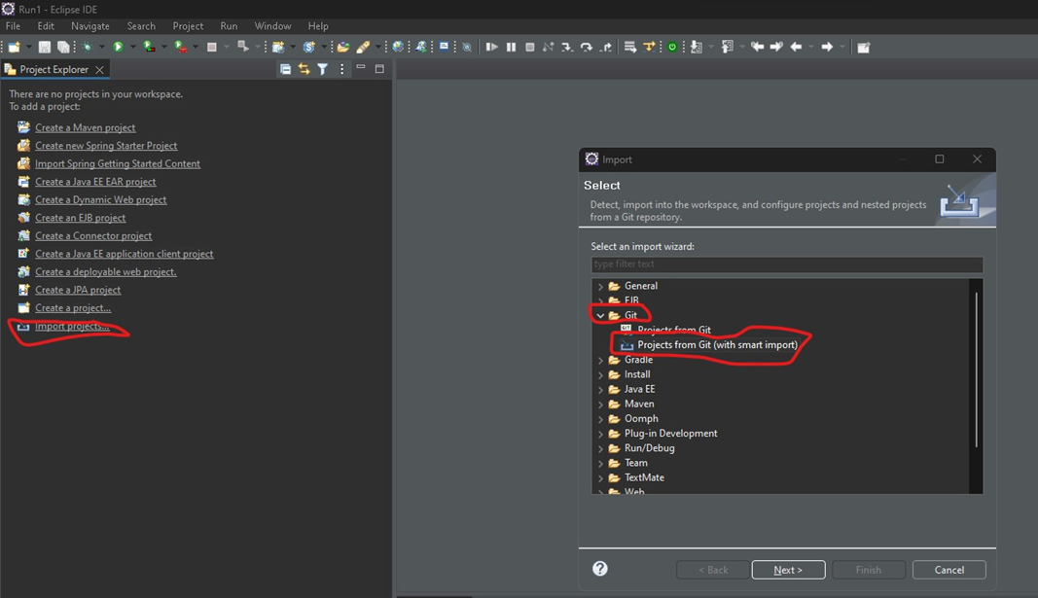

6. Clone URL

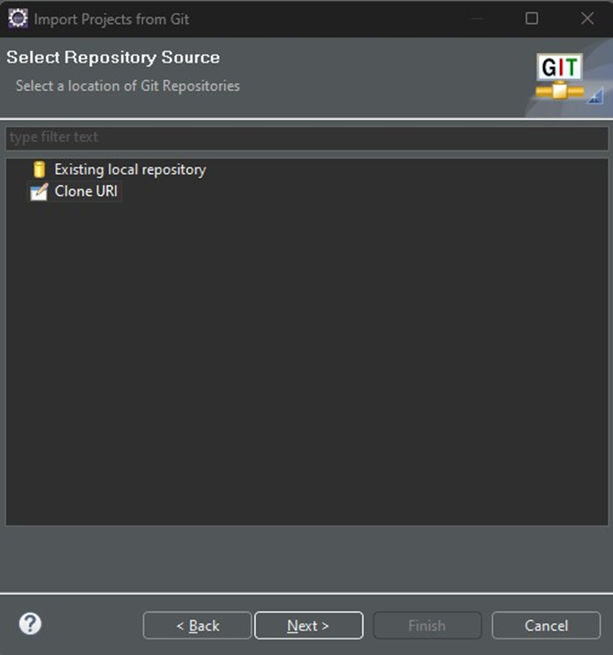

7. Copy that URL from step 2 and select Next >

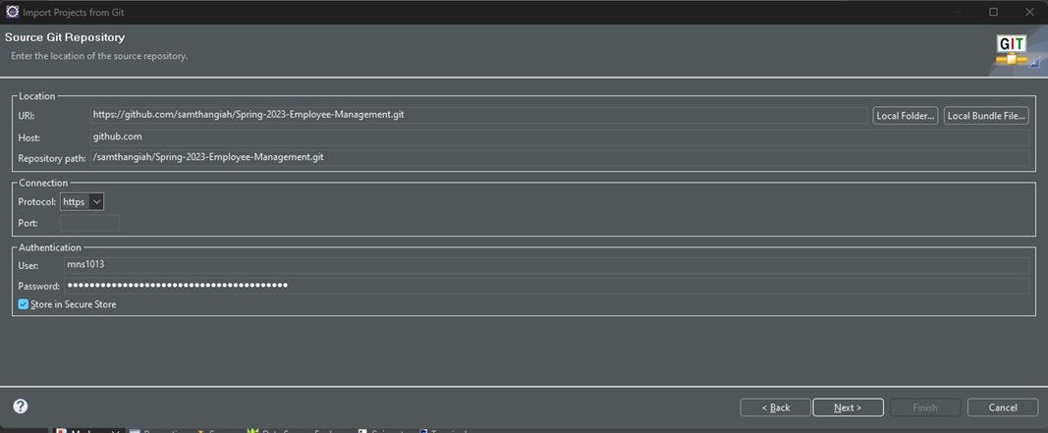

8. Select Next >

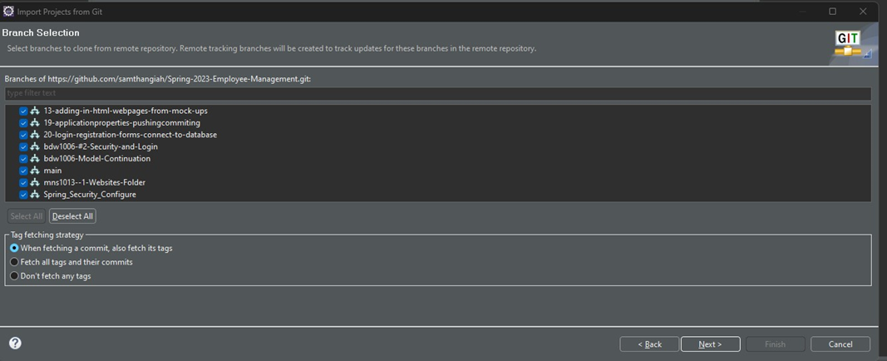

9. Select Browser and then save

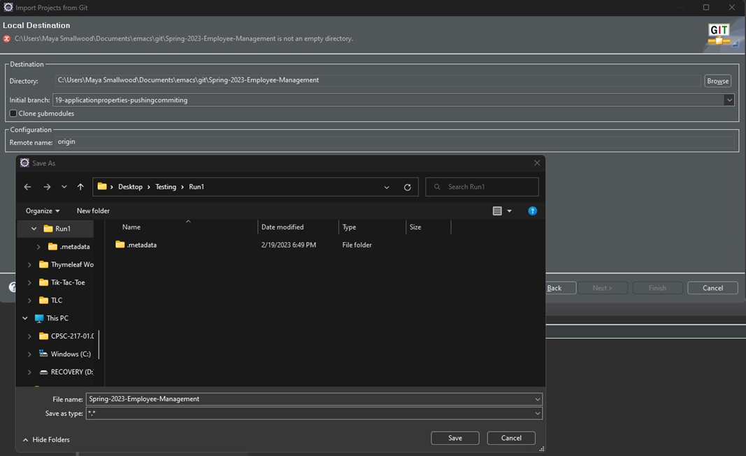

10. Select Next

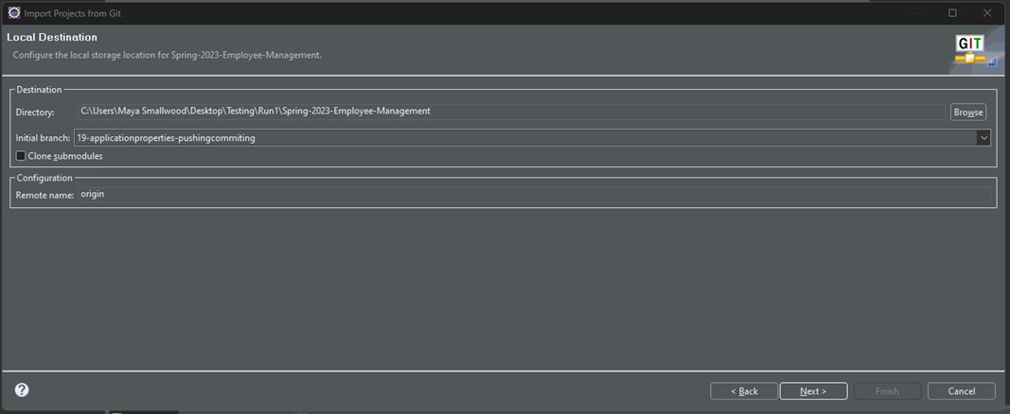

11. ONLY Select "Spring-2023-Employee-Managment\EmployeeDatabaseManagemnet-UpdatedVersion\--- Import as Maven and then select Finish

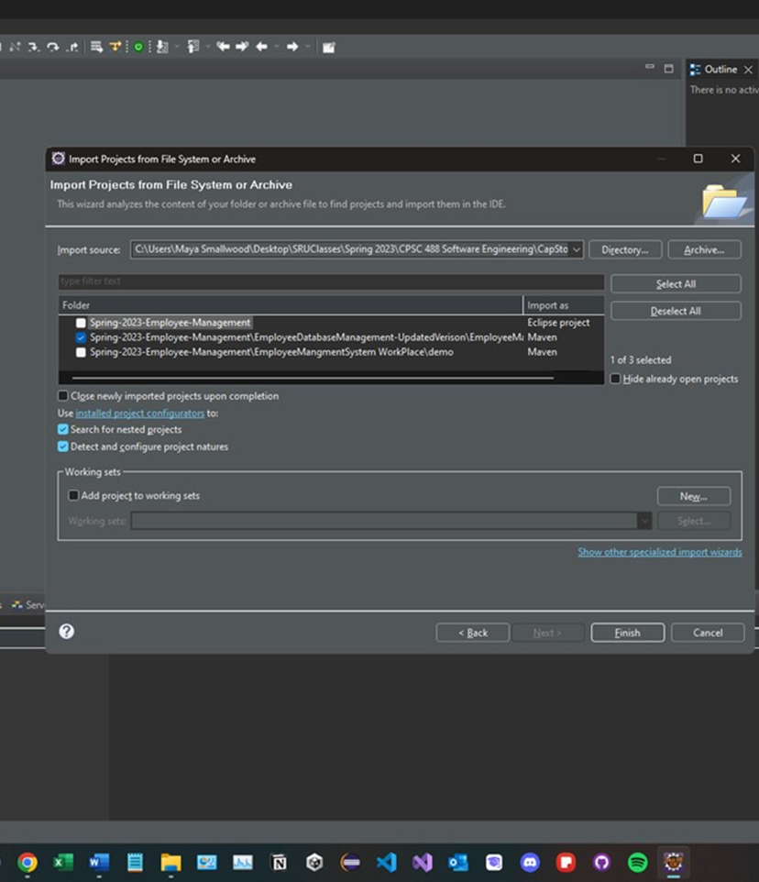

12. Project will build itself in and you will see it on the left hand side

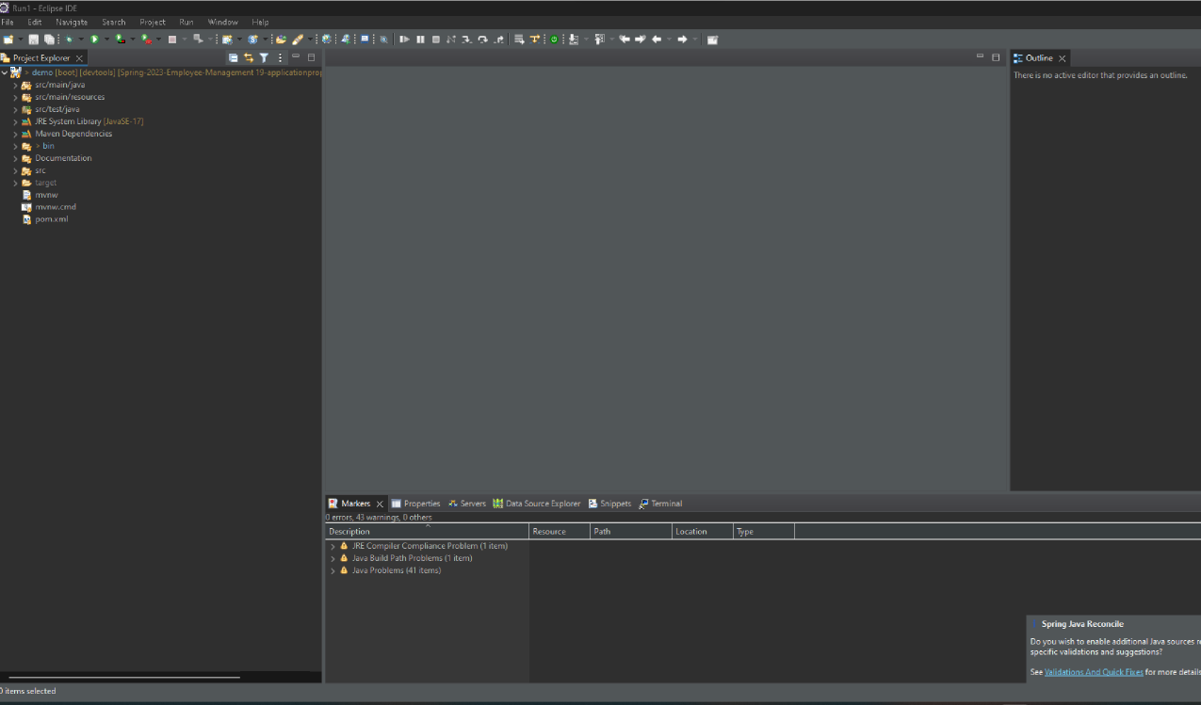

13. Next in our application.propetries which creates the database you have to change the settings to connect to your database, therefore please do the following:

select the dropdown for src main resources

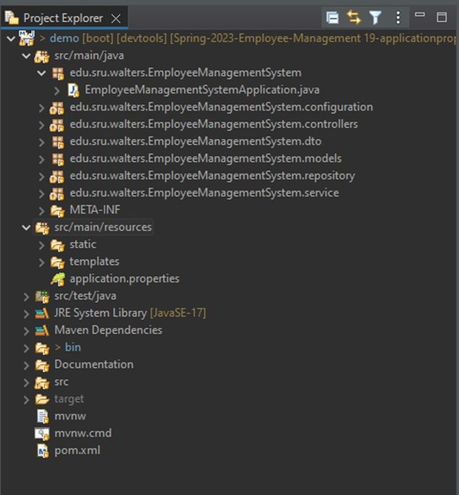

Double click application.properties

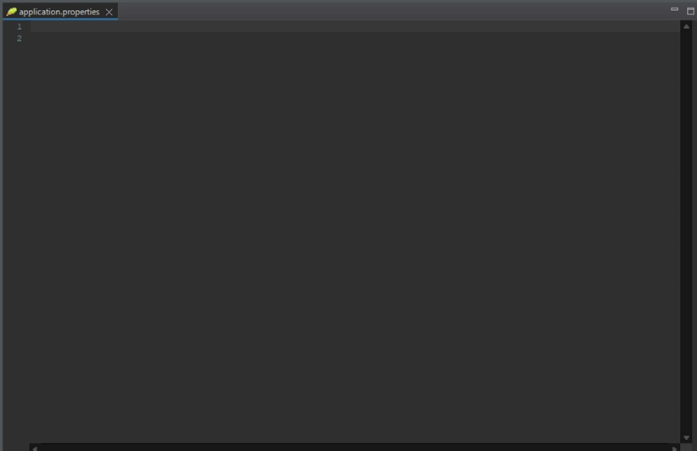

And paste in the following:

spring.jpa.hibernate.ddl-auto=update

spring.datasource.url=jdbc:mysql://localhost:3306/employeedata?createDatabaseIfNotExist=true

spring.datasource.username=root

spring.datasource.password=2023CPSC!!

spring.jpa.properties.hibernate.format_sql=true

spring.main.allow-bean-definition-overriding=true

spring.thymeleaf.cache=false

spring.thymeleaf.prefix=classpath:templates/

spring.datasource.username= & spring.datasource.password= Will be your local MySQL Database information.

14. Next to run our project:

select the following:

sru/main/java

edu.sru.walters.EmployeeManagementSystem and double click

EmployeeManagmentSystemApplication.java

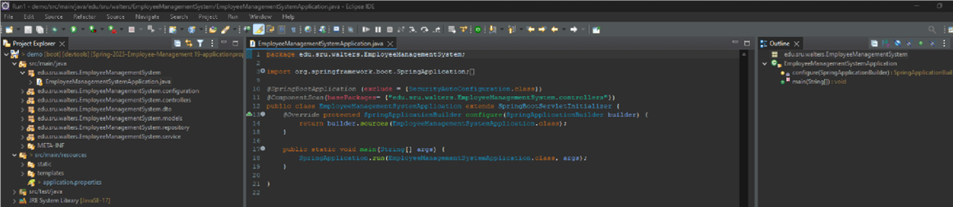

15. Then right-click anywhere inside

EmployeeManagmentSystemApplication.java folder

Go down to Run As

Spring Boot App-(Will only appear if you have installed spring tools)

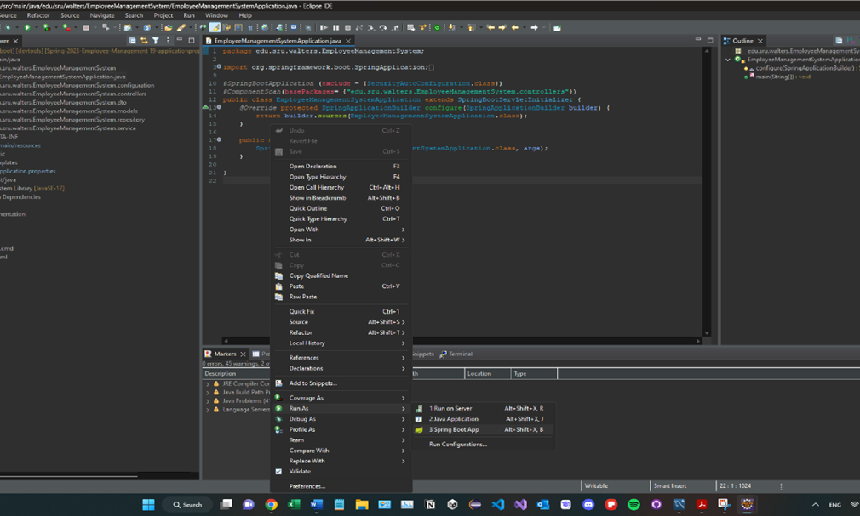

16. SpringBoot will run

**\*Please Note, if there are any runtime errors you may have to close and reopen the project. Sometimes the project doesn't build all the import files at the time of importing.\***

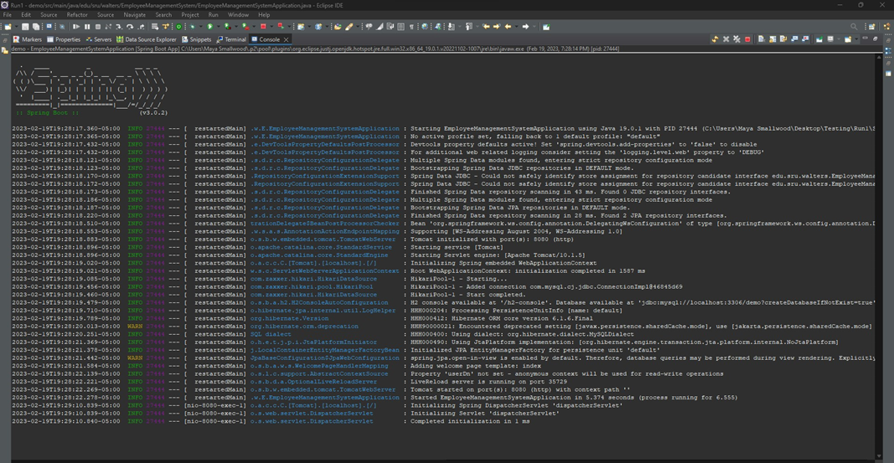

17. Open up and web-browser, and then type in the following: localhost:8080

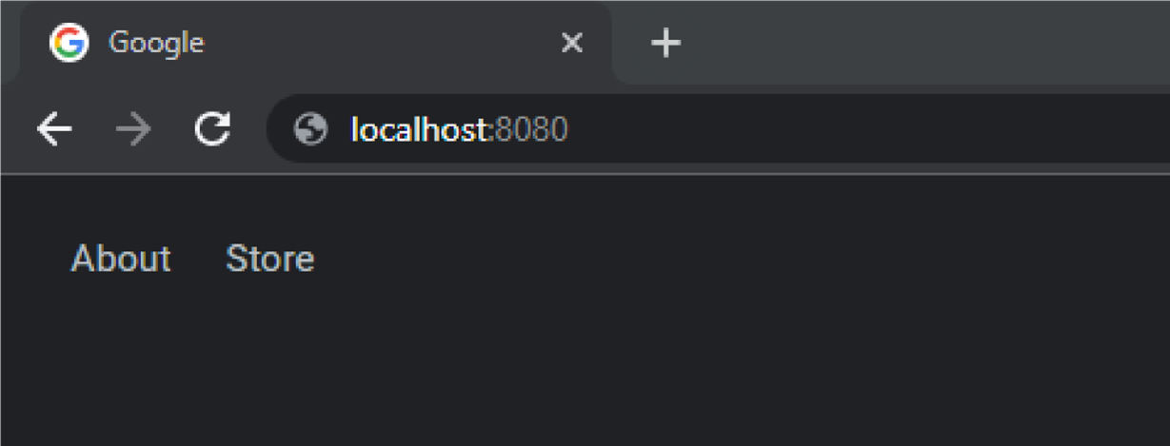

18. You will then be taken to our HomePage.

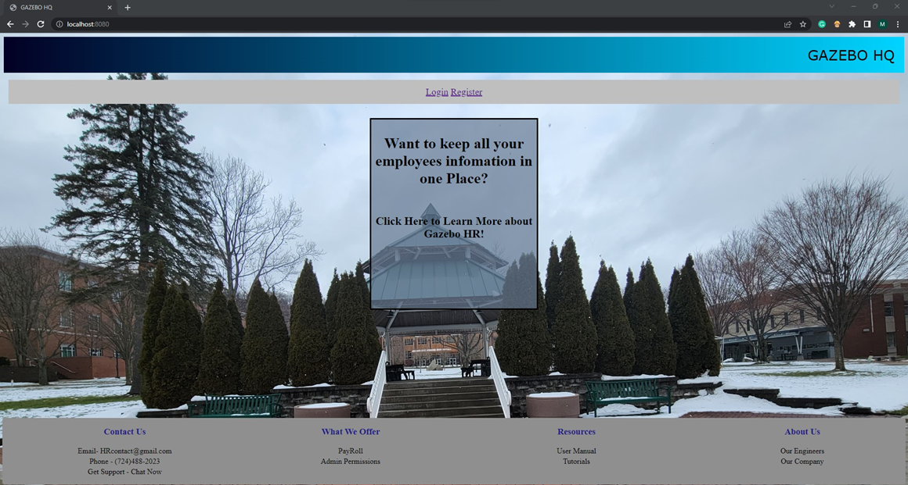

19. Next is to install data into your database using our data.sql file.

Pre-Populate Database Importing a SQL script file

1. Drop the schema corresponding to our database name "employeedata" to ensure that the system can add in the new data. To do this, right-click on the schema and select "drop" in MySQL Workbench. (NOTE: You may skip dropping the schema if this is your first time running our program.)

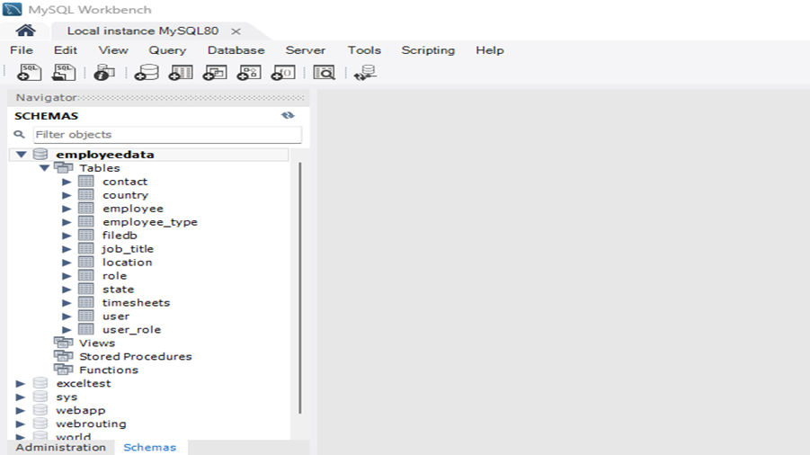

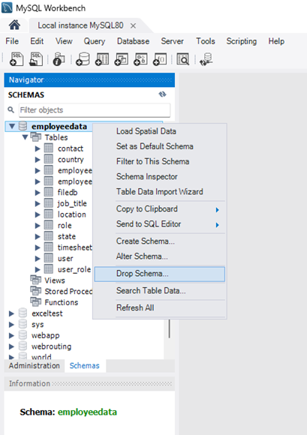

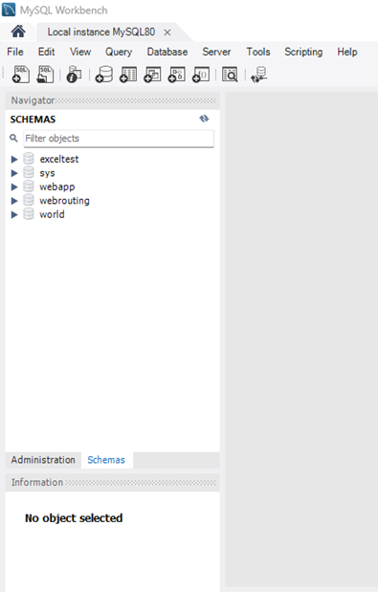

1. After importing our project to Eclipse IDE 2022-12, navigate to the "application.properties" file and ensure that the "spring.datasource.username" is set to "root" and that the "spring.datasource.password" is updated to your Workbench password. Failure to change the password will result in an inability to create or access the database.

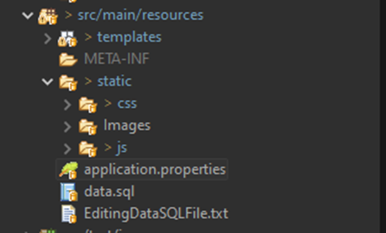

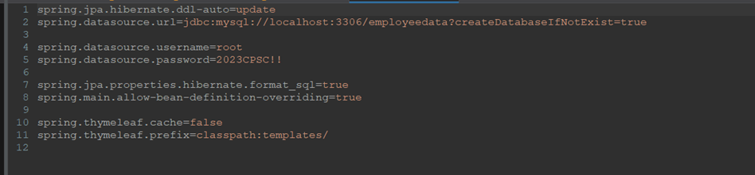

1. Right-click on our project and select "Run As SpringBoot App" to start the project. The system will display a message indicating that the project has been created successfully.

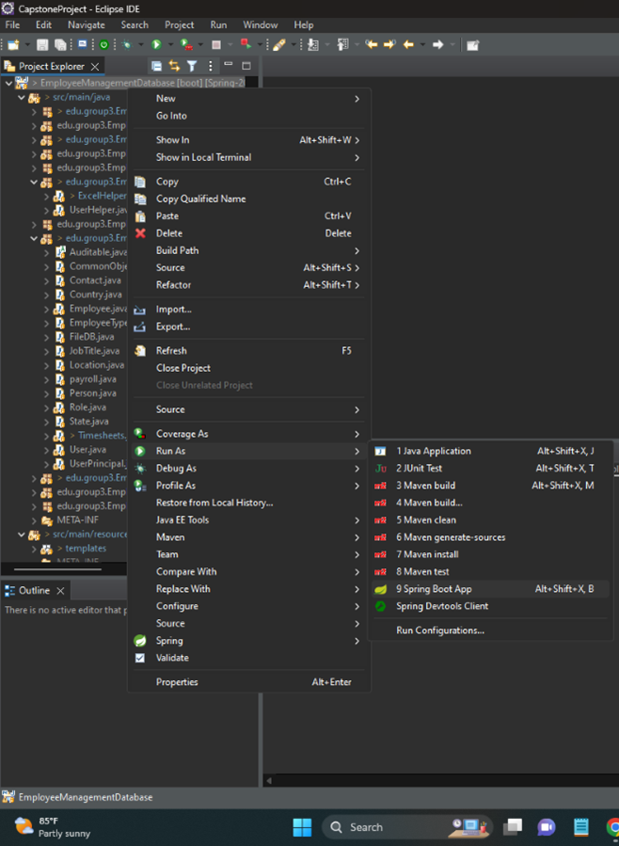

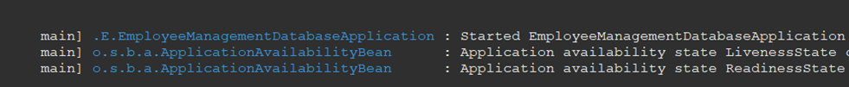

1. Return to MySQL Workbench and refresh the Scheme list for the database to display.

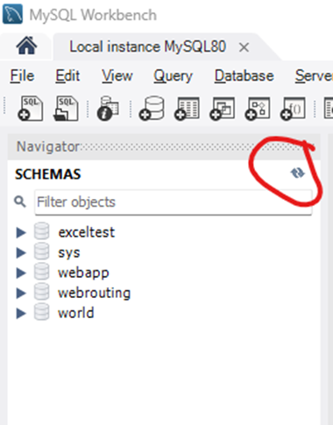

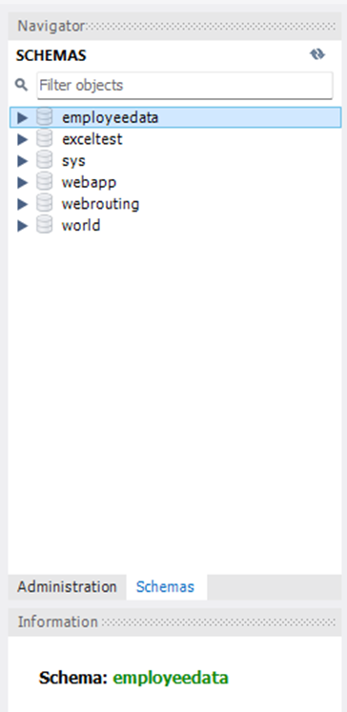

1. Double-click on the "employeedata" schema in the list to make it bold, indicating that you are focusing on this database. Then select Administration. Then select Data Import/Restore.

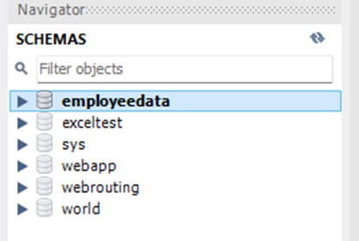

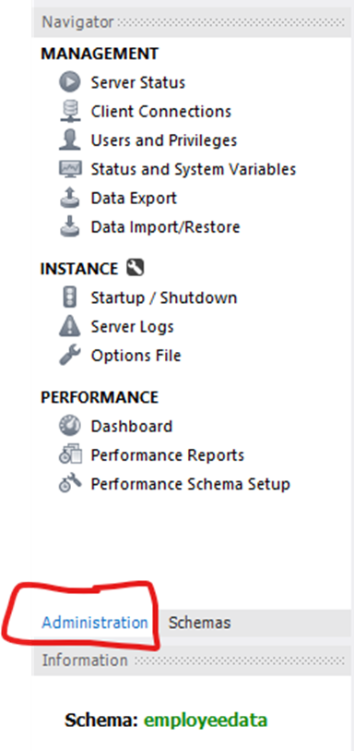

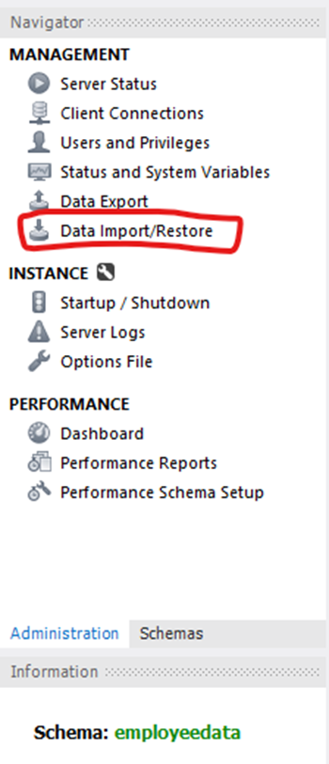

1. Next Select Import from Self-Contained File, then point to where the project is stored, and select the data.SQL file, and finally make sure your Default Target Schema is set to the correct one.

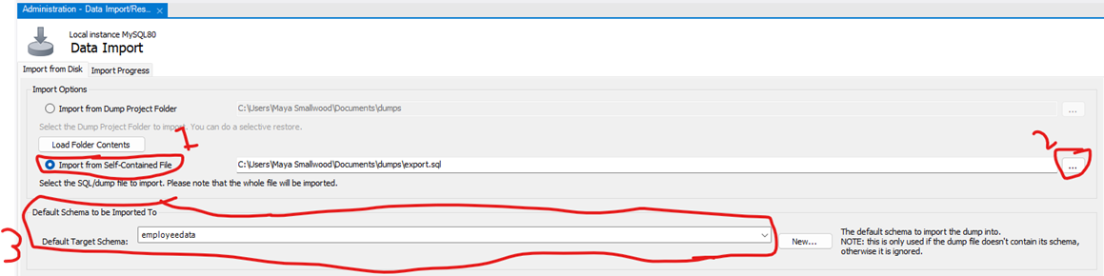

Navigate to the "data.sql" file located in YourMainDict\EmployeeManagementDatabase\src\main\Docuementation/Data where you have the project stored

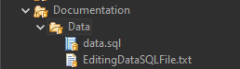

Then select Start Import

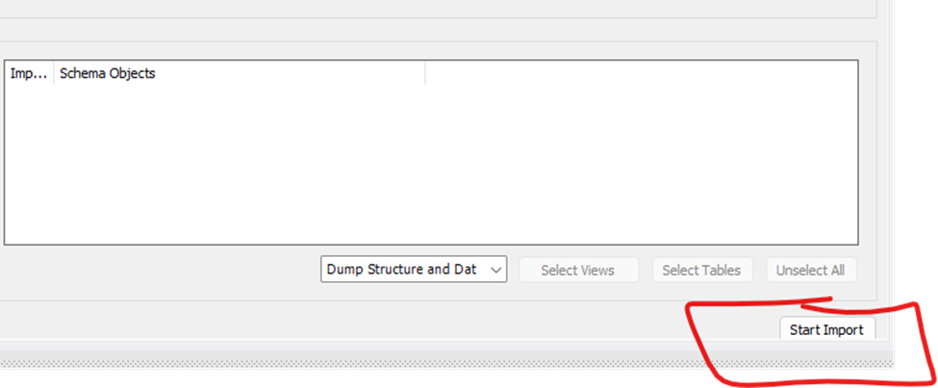

1. Once it is done running and importing data it will look like the following:

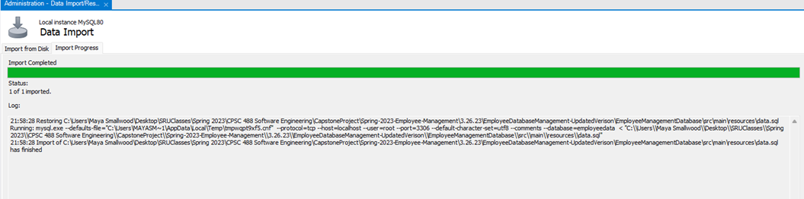

1. Next go back to Schemas and Refresh the schema list again and select the drop-down menu to display the tables.

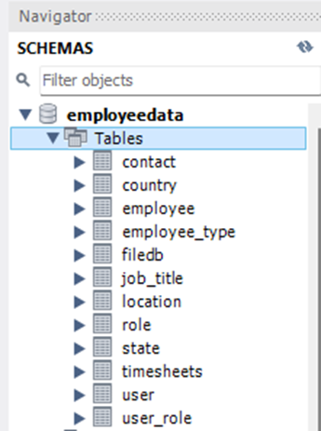

1. To ensure that the data was entered correctly, select "user" and right-click to display its information. The table will now be populated with data from the data file and will display on the corresponding pages of our project.

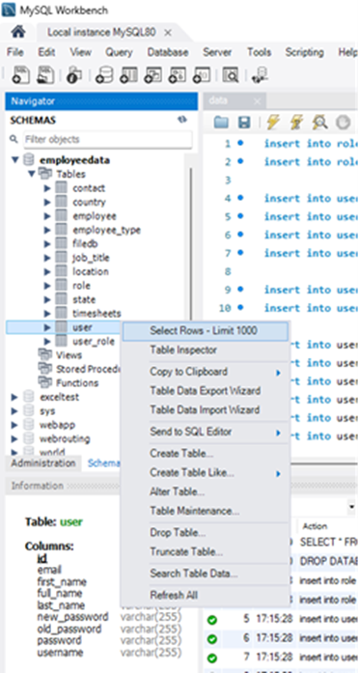

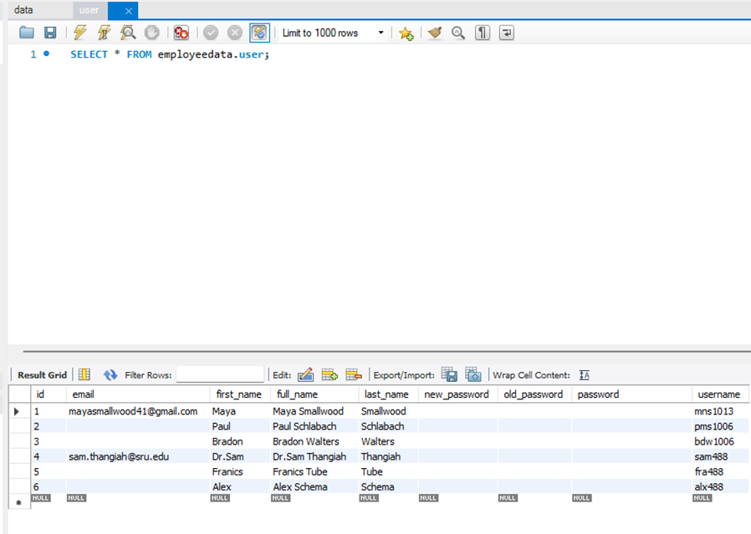

## User Manual

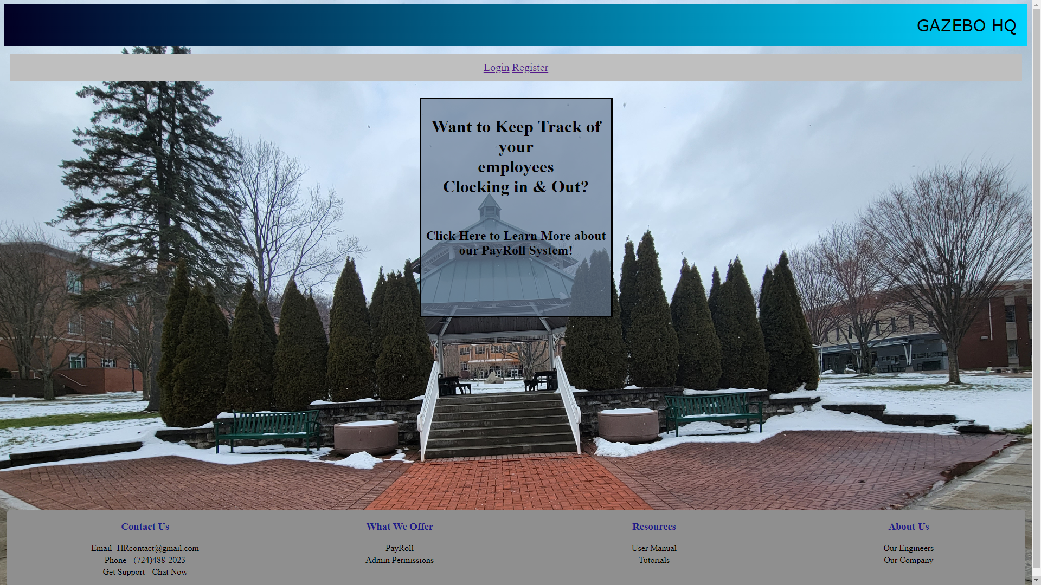

Figure 1. Landing Page

* Upon running the application, the user will see this landing page
* They will have the option to Login or Register a new account

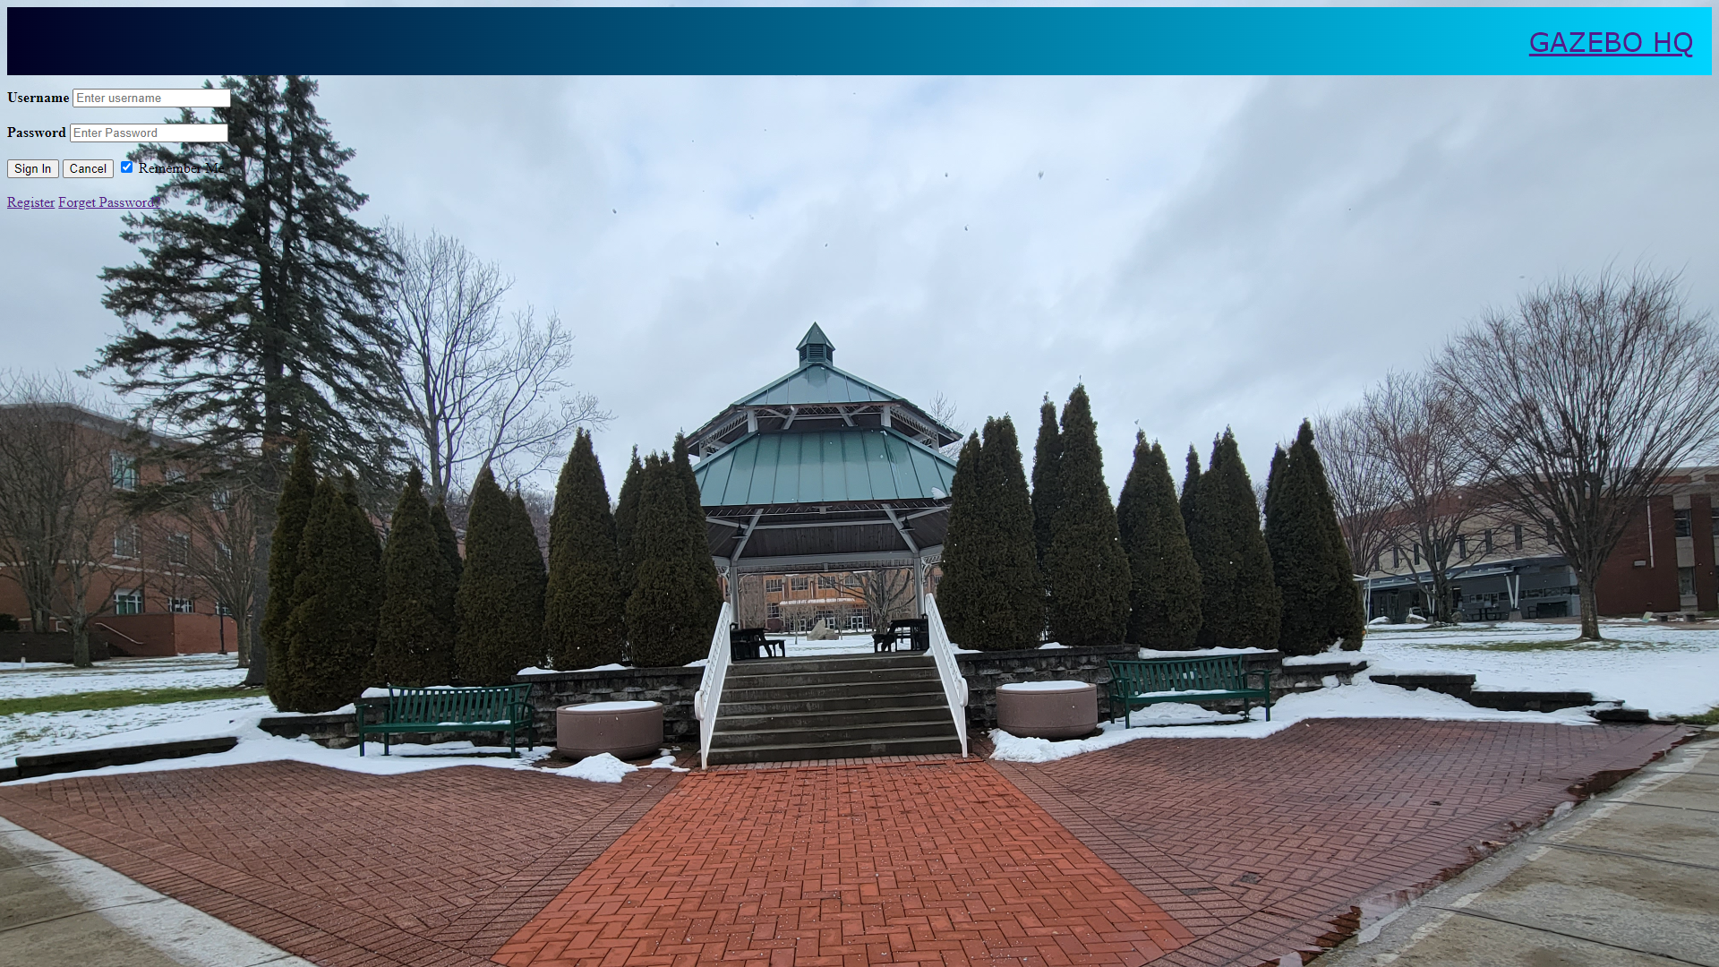

Figure 2. Login Page

* Once on the login page, users will sign in using their username and password associated with their registered account.
* If you have imported the **data.sql** file you will have to select “Forgot Password?” to create a password. To login in with one of the import user’s username.
* If you do not have a account you can also reach the Register page from here by selecting “Register”.

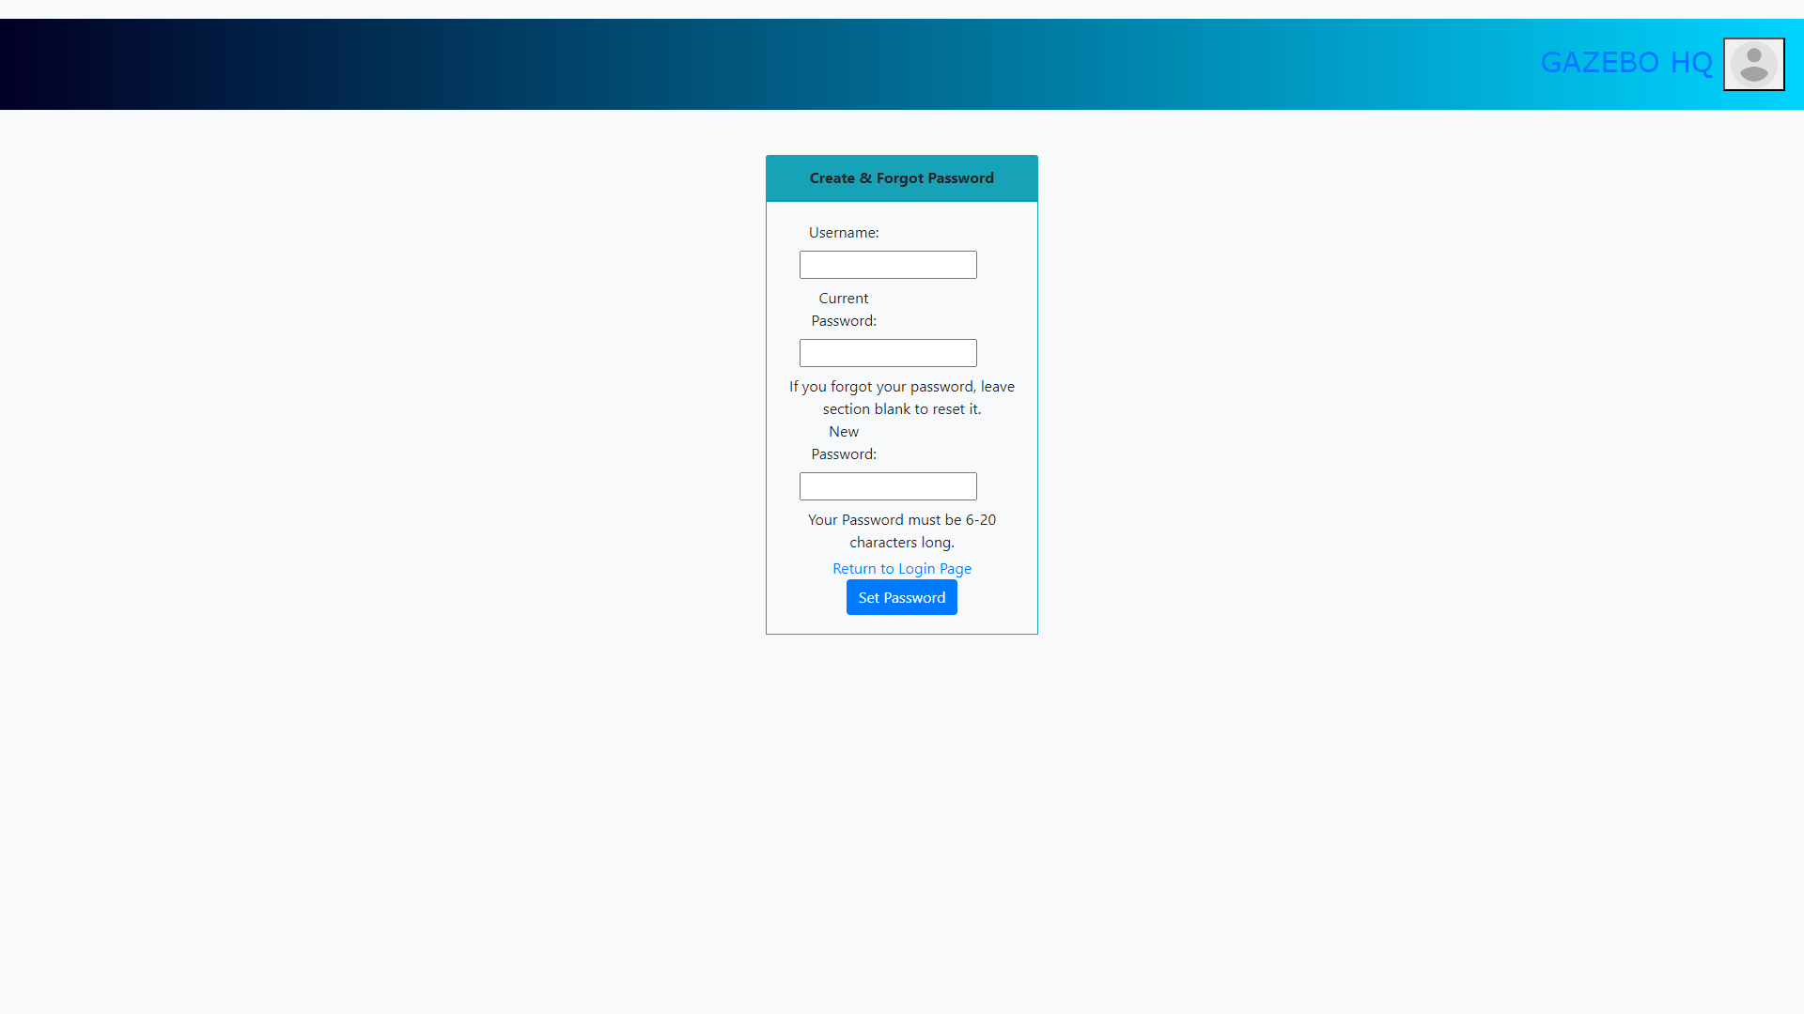

Figure 3. Forgot & Create Password Page

* On the Create & Forgot Password page, users will be able to reset their password if they forgot it
* Or if they are creating a password after they had their user data imported
* If the user is unable to remember their password or they are creating a new one for a account, they would leave the the “Current Password” textbox empty
* This also allows the user to return to the Login page after they have set their password

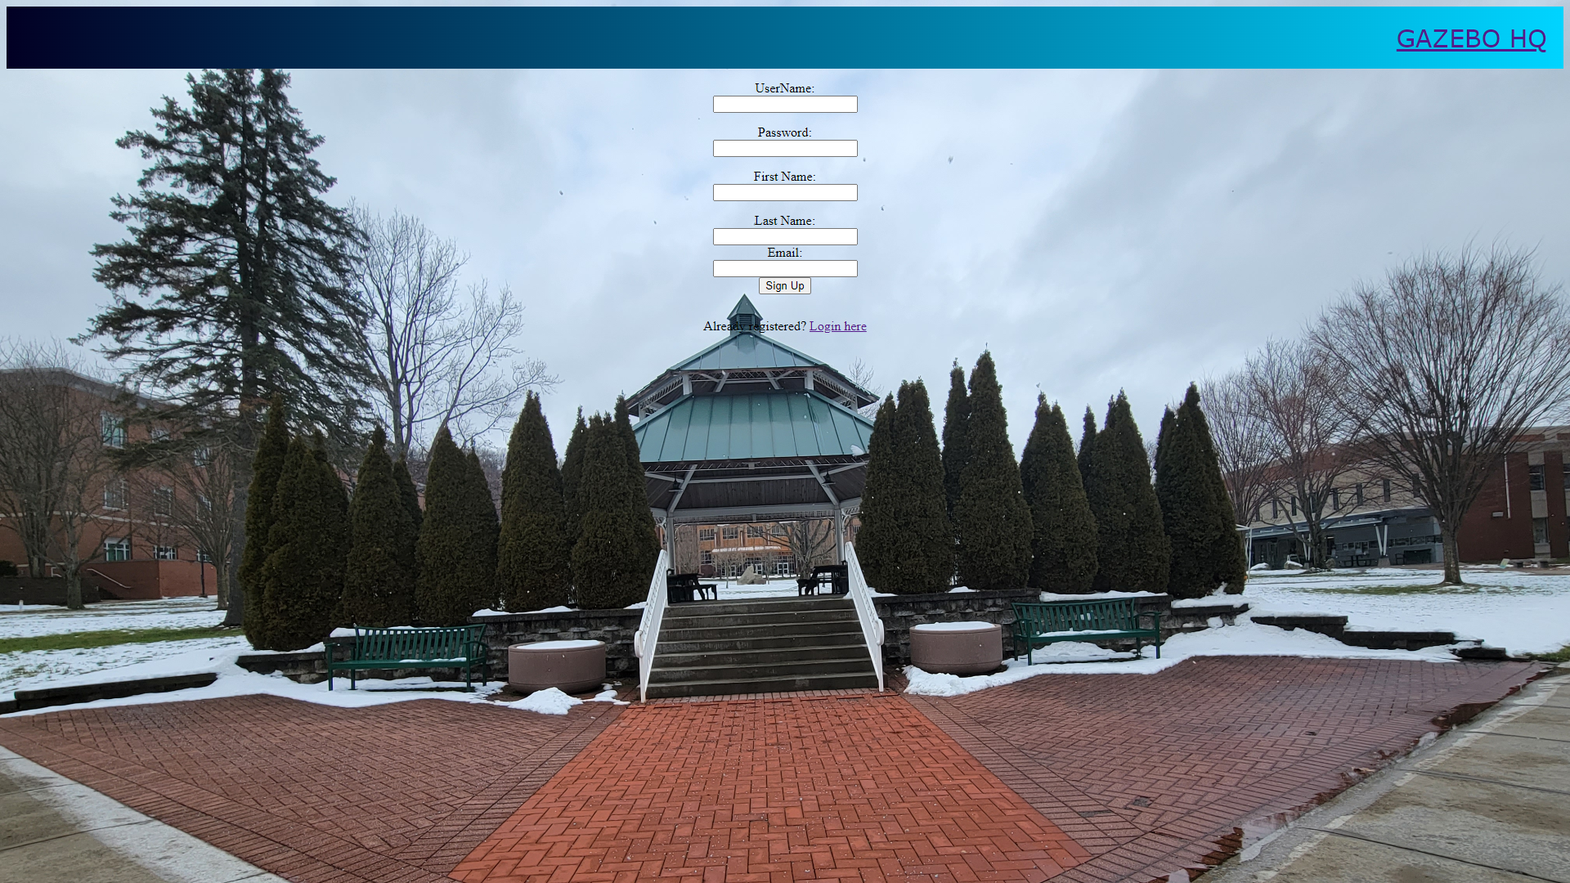

Figure 4. Registration Page

* Upon reaching the registration page the user will be prompted to enter an username, password, first, and last name
* Once entered the user will select the “sign up” button or if they mistakenly clicked registration they may click “Login here” if they already have an account

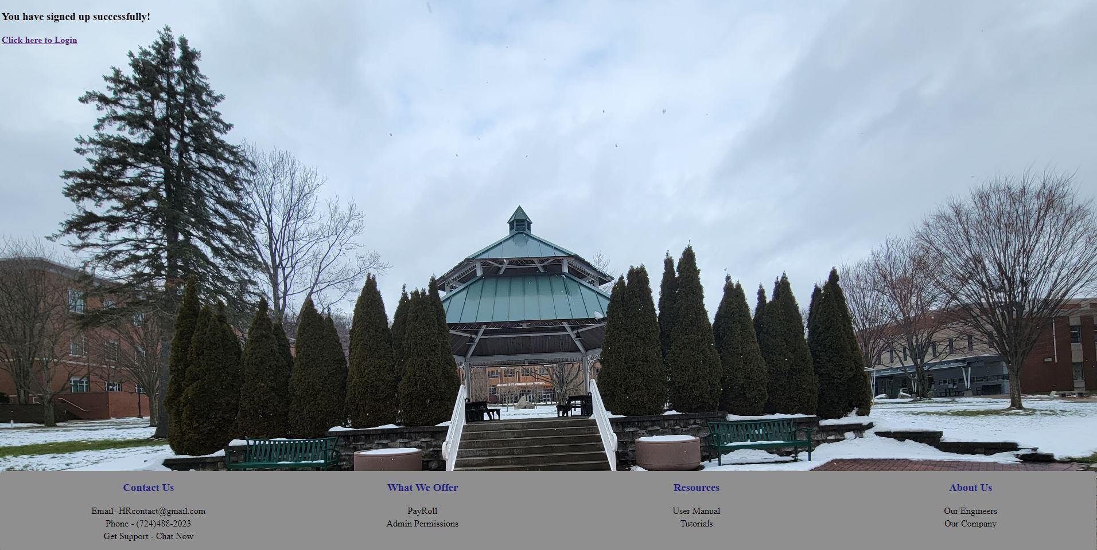

Figure 5. Registration Successful Page

* Once clicking “sign up” users will reach a screen prompting them  
  to log into the system



Figure 6. Login Successful Page

* You will receive this page, once you have login successful, if not you will be returned to the login page to re-enter your information

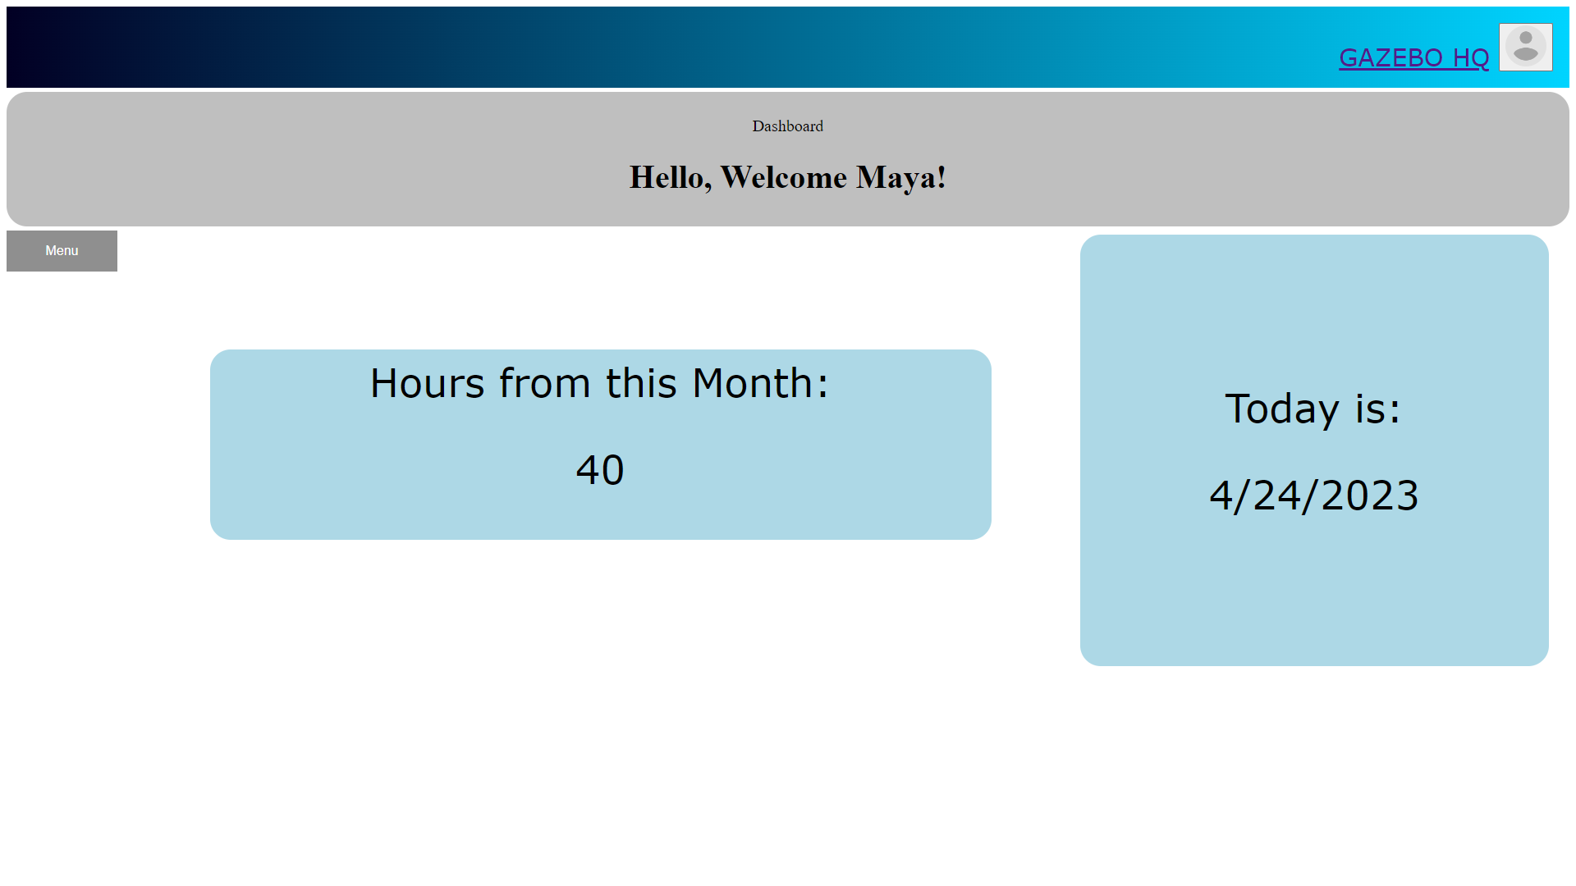Figure 7. User’s Dashboard

* Once logged in, users will be sent to the dashboard. On this page users can see what today’s date is and how many hours they have worked this pay period month
* If users hover their mouse over the menu button. A dropdown menu will appear showing users their different options within the application
* If users hover their mouse over the top right avatar icon they will see the “Sign Out” option and a option to go to “Settings”

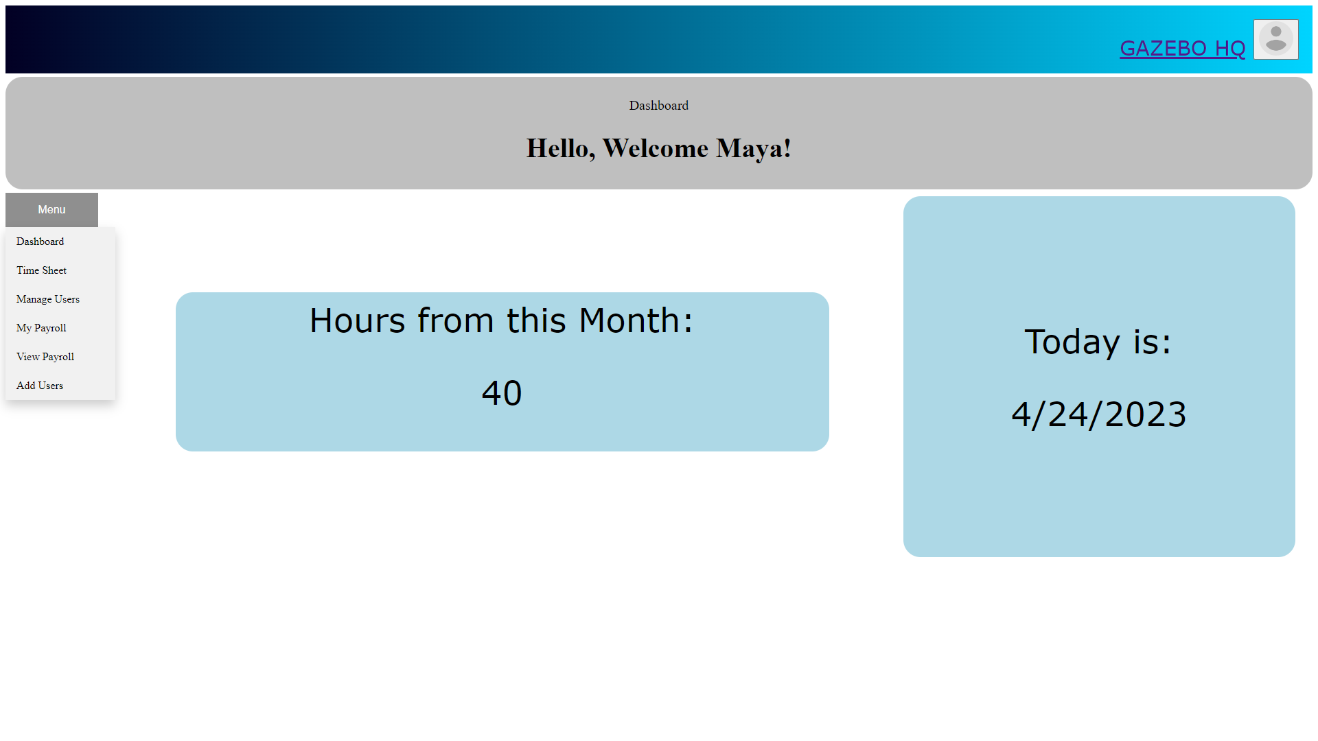

Figure 8. Navigation Drop-Down

* Hovering over the Menu button will allow the user to travel to one of the following locations
* Additionally thanks to security authentication, certain pages are only accessible based upon the user’s login role
* Below explains what each page is capable of

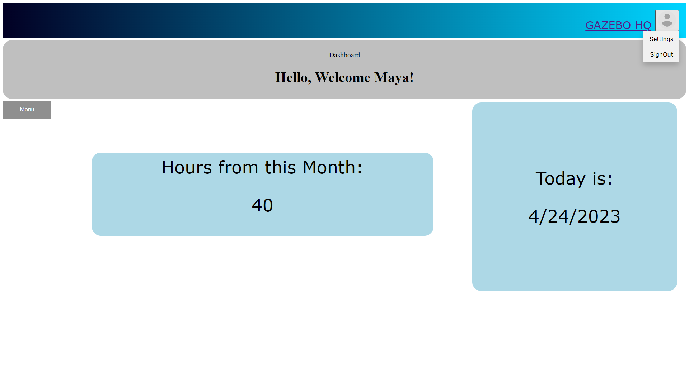

Figure 9. Location of Settings & SignOut

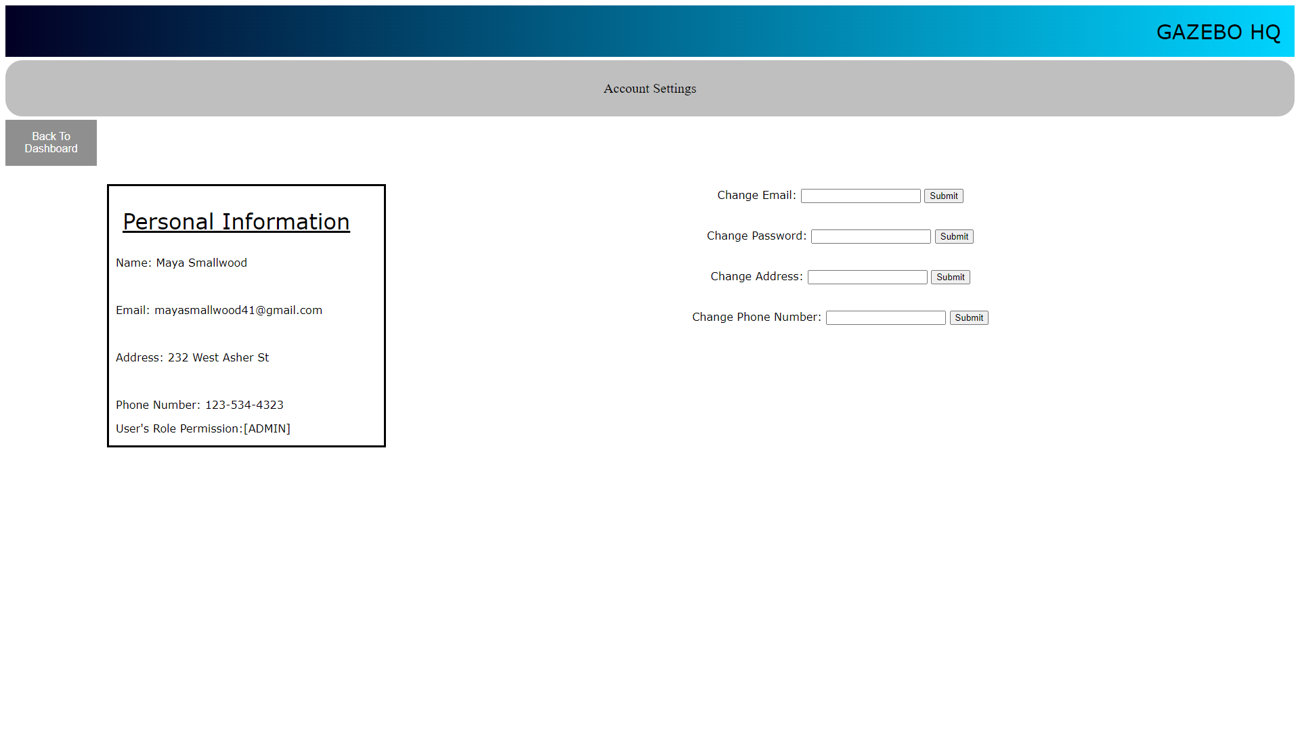

Figure 10. Account Settings

* Here the user can see their personal information that is stored in the database
* Additionally the user can also set or change that following information

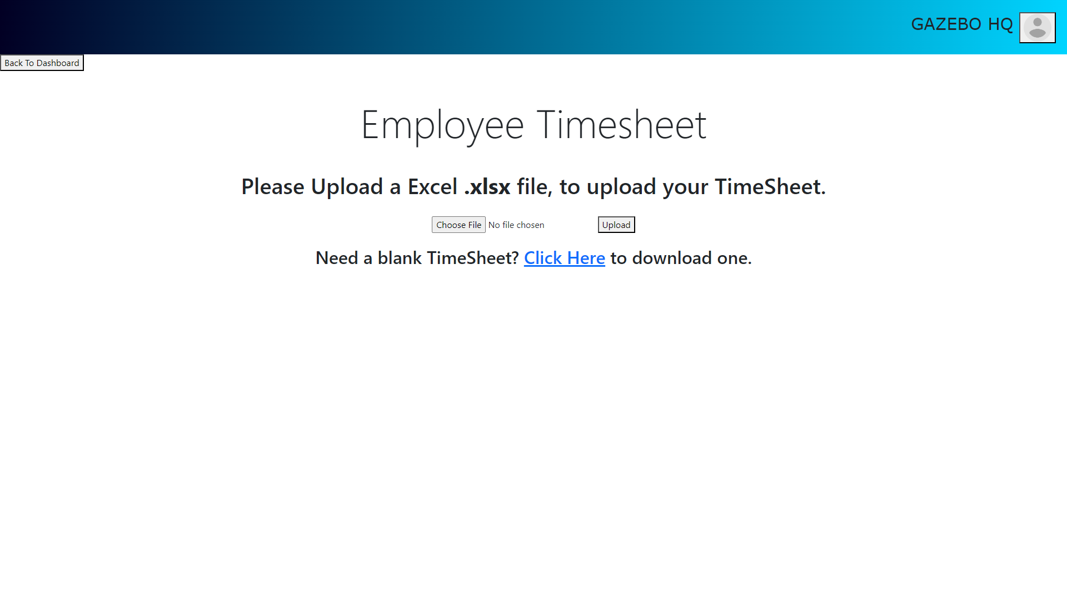Figure 11. Submit Timesheet

* Here Users can download a blank timesheet, in the form of a Microsoft excel .xlsx file and upload it to the MySQL database system to store and to populate the PayRoll pages

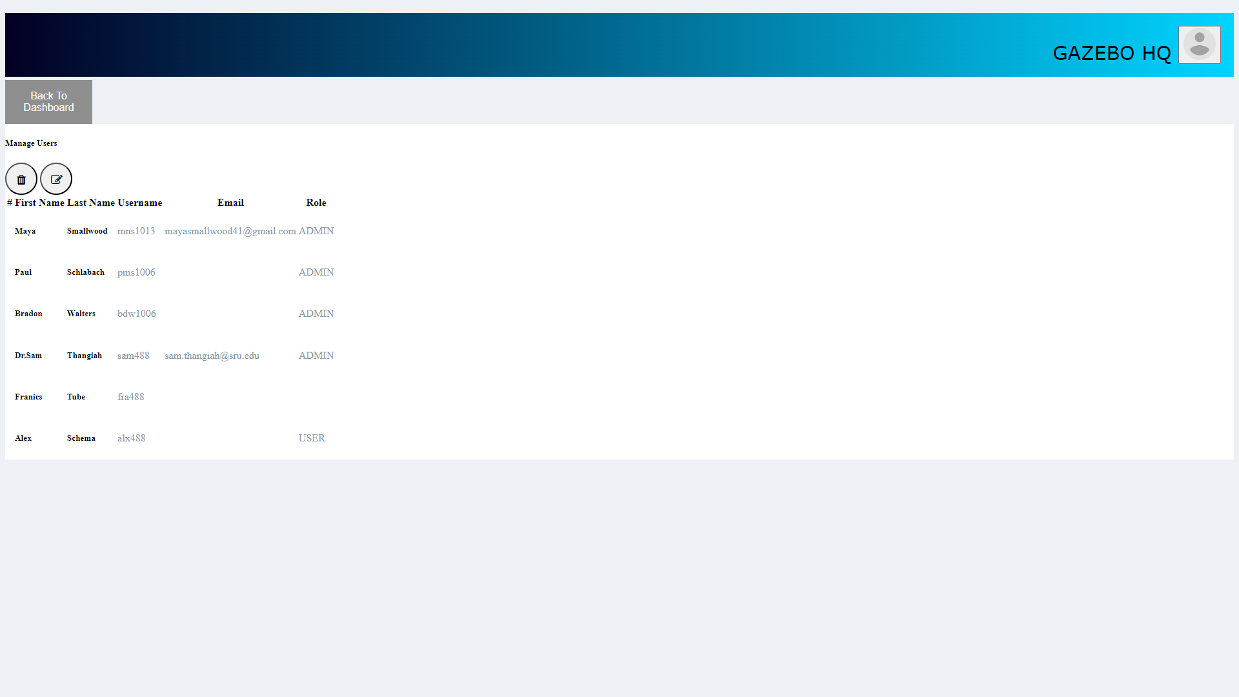Figure 12. Manage Users-Admin Access

* This page is only accessible through the Admin Role, here Admin users can view the list of users stored in the database
* They also have the ability to edit those’s user’s Role

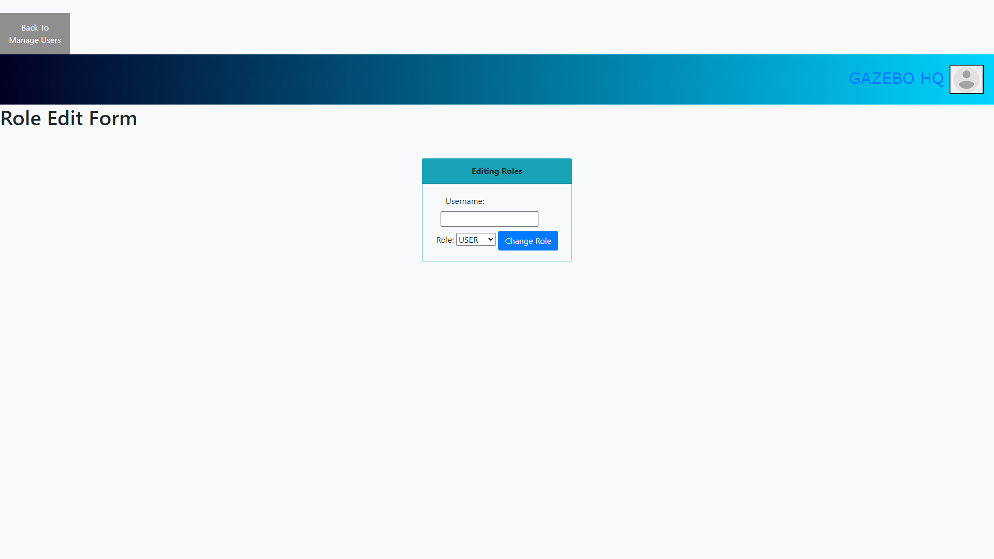Figure 13. Role Edit-Admin Access

* Here Admin can enter in a user’s username and select what role they will now have
* Note: Every new user that registrations will automatically get the User Role permissions

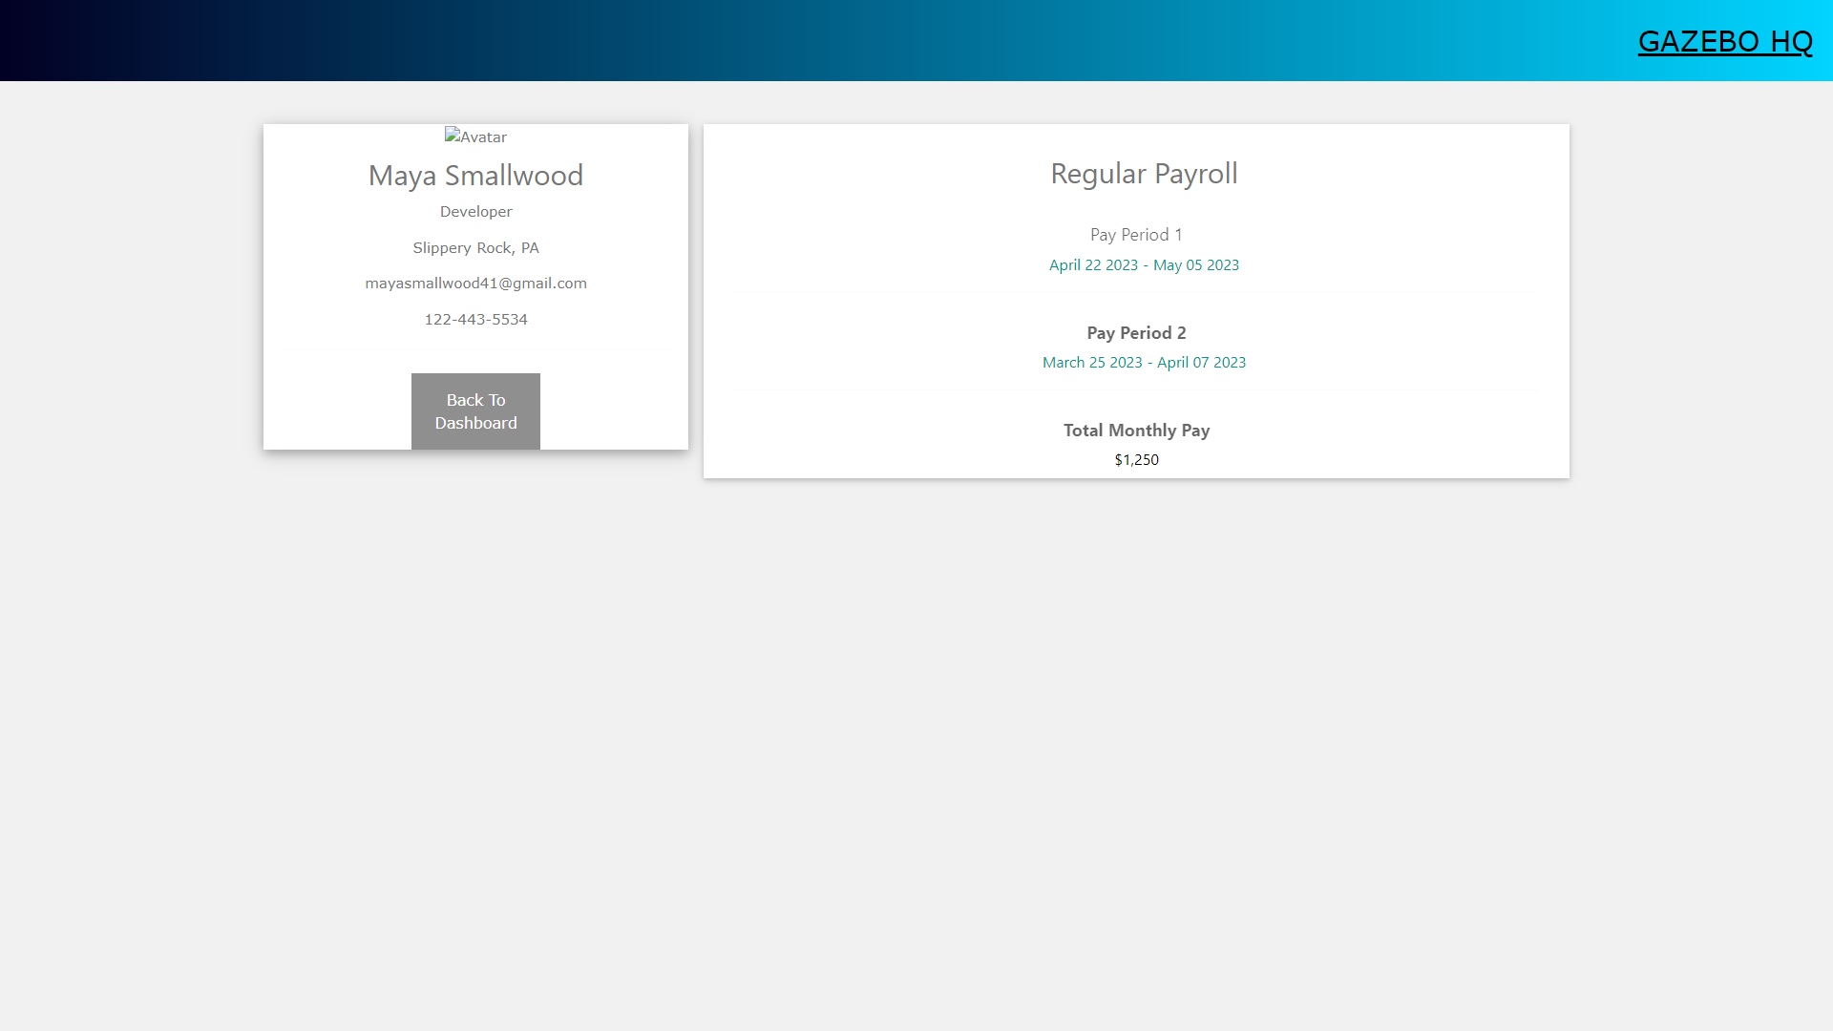Figure 14. PayRoll-User Access

* This page is accessible by both User and Admin Permissions
* This will display a user’s personal information based upon the pay period, month pay, and employee information

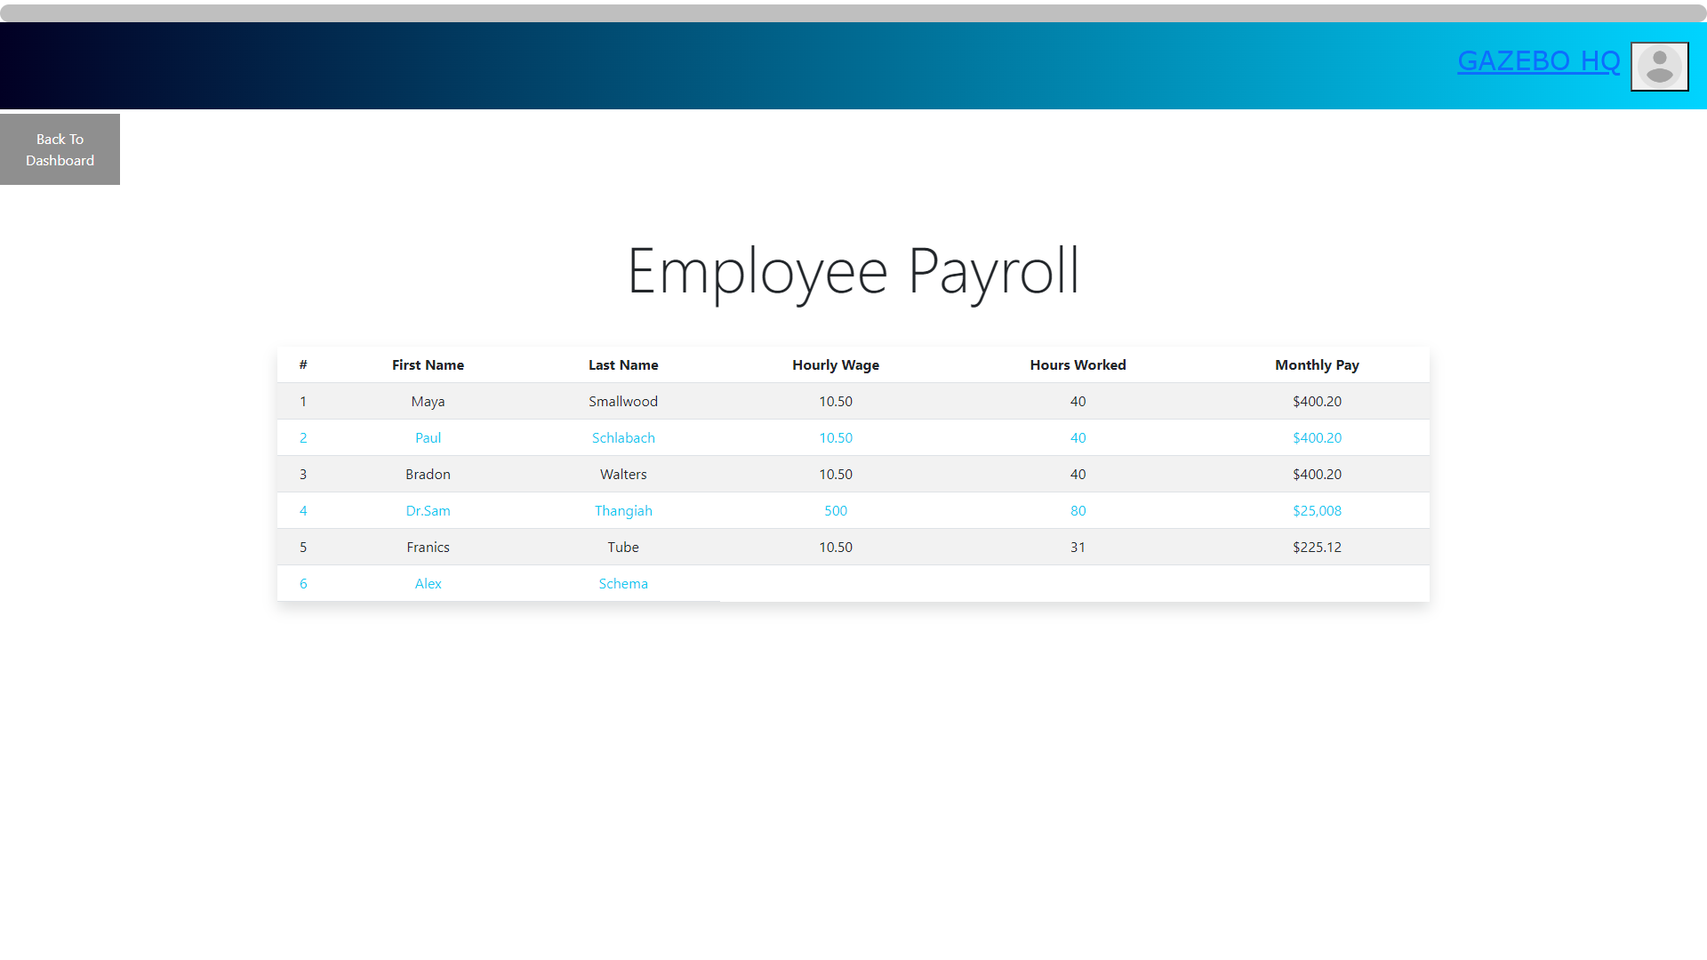Figure 15. PayRoll-Admin Access

* This page is only accessible by Admin users
* Here will display all users, including themselves with an overview of all page wages, hours worked, and their total monthly pay

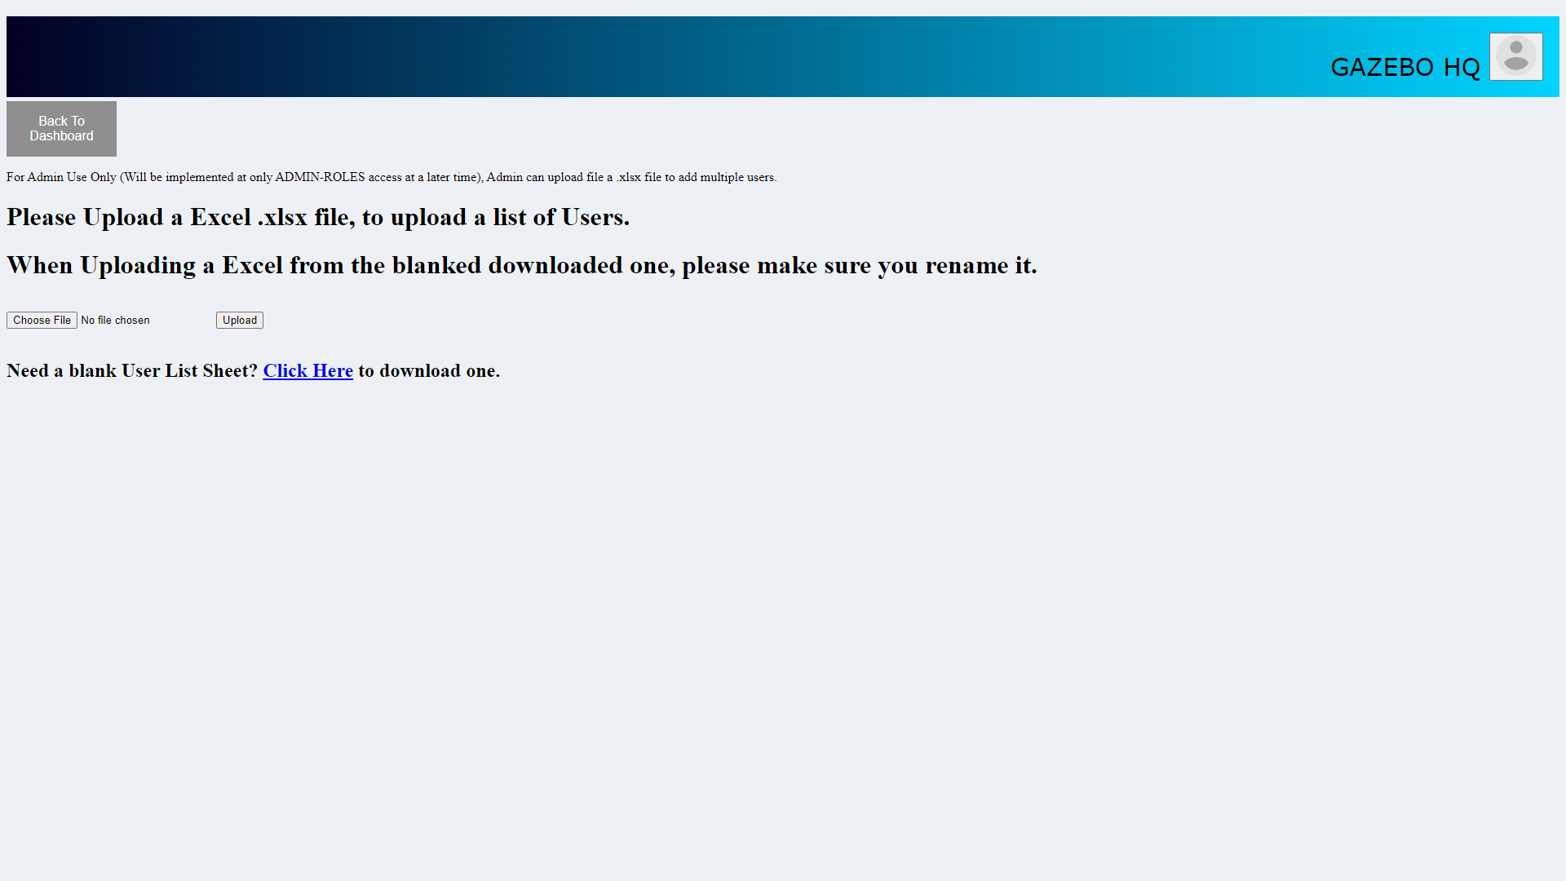Figure 16. Add Users-Admin Access

* Here Admin’s can import a excel file with a bulk list of creating new users
* Additionally if the password field is filled in, the system will auto encrypted the password allowing those new users to automatically be allowed to login

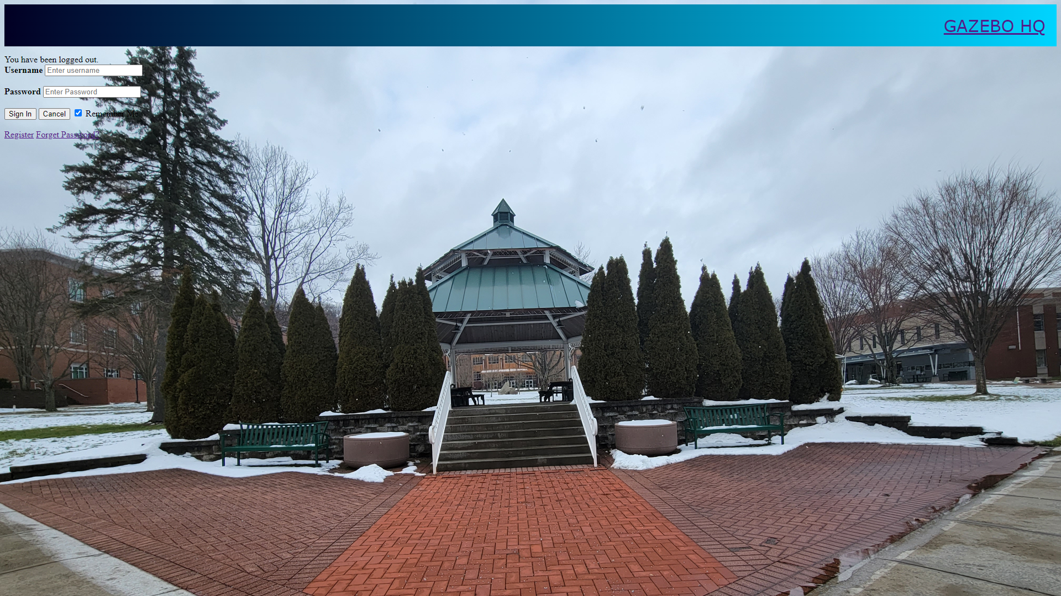  
Figure 17. SignOut Page

* Once the user selects “Sign Out” they will receive this page stating they have successfully done so

# 

# 

# **Testing**

## JUnit Testing

JUnit testing was added for models to test the information that could be passed in to the models by the User. This included things such as passing in and testing personal information for a user/employee as well as information based on locale such as Country and State information. The code behavior is tested against expected values that are asserted as parameters that are passed in.

These tests were made so that they could easily be changed to fit the needs of anyone that has need to. The test can easily be reconfigured to test things that were not completely tested as well as ease of creating test case failure scenarios. The JUnit testing portion of the program is scalable alongside the program in that you can easily add tests that are modeled after the ones that are already located within the testing folder. Additional tests can be added for the Controllers and Service layers.

# **Documentation**

## Technical Manual

Contents:

Overview

UMLS

Implementing Registration & Login System

Implementing Importing & Downloading Excel files

Pre-Populate Database Importing a SQL script file

Resources

Application Properties

# 

Overview

This workspace is intended to act as an addition to an existing project or can be configured into something more; this workspace is made up of an employee system database that utilizes MySQL Workbench to manage employees while using Spring Boot Thymeleaf Model, View, and Controller (MVC) framework to develop the web applications. The program allows the registration of new users, editing of users, and deletion of users. It also has login authentication based upon whether the user’s role is Admin or an Employee taking the user to the apportion landing page. It enforces the password policy using the Spring Framework Security of the BcryptPasswordEncoder library. While also using Models that create entities and connections to MySQL. To use this program with their projects, programmers should copy the classes, controller format, models, and security config into their projects. The Users and UserRepository may need to be configured for your likely, considering that our main classes work with our registration pages..

UMLS

# 

Figure 1. Case Diagram for Admin Control

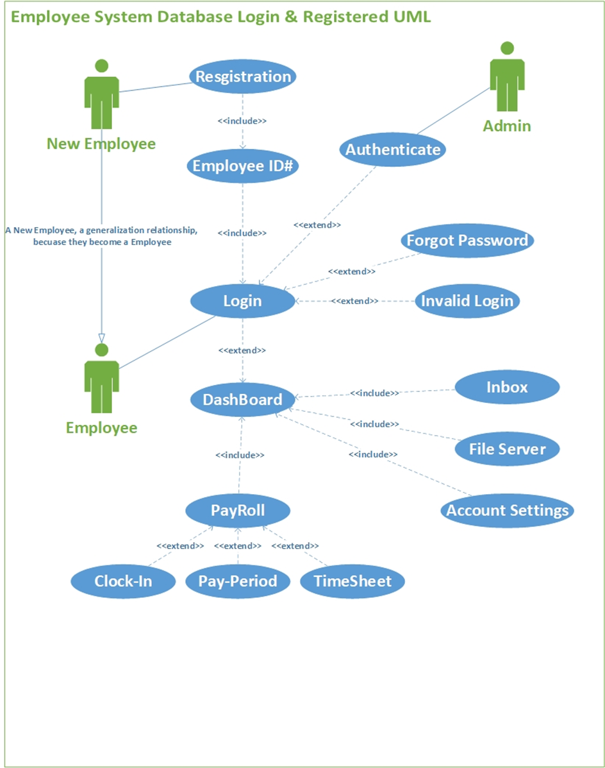Figure 2. Case Diagram for Employee Control  
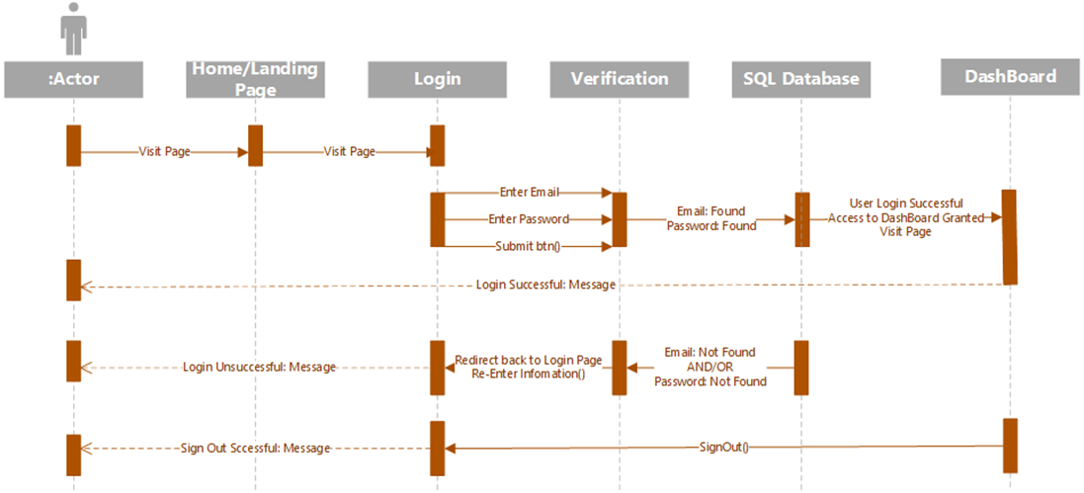  
 Figure 3. Sequence Diagram for User Login

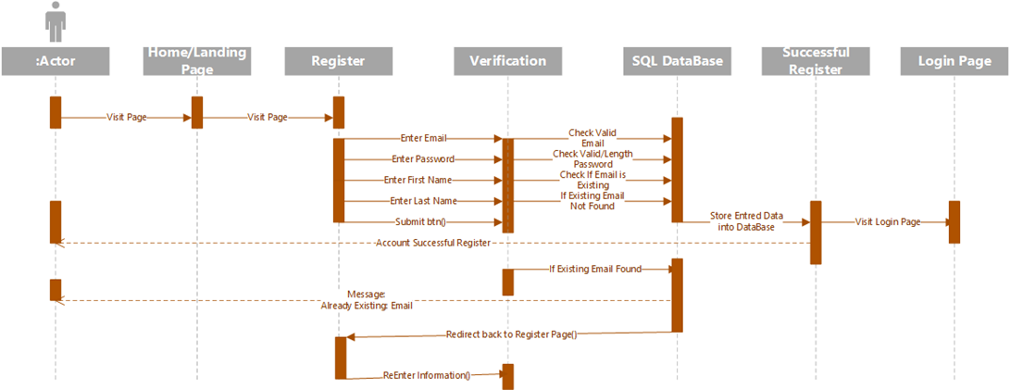

Figure 4. Sequence Diagram for User Register

# 

Implementing Registration & Login System

*(For more references in relation to Thymeleaf documentation please look at our “SpringBoot Thymeleaf documentation” document)*

**Configuration, implements security authentication into the project’s webpages:**

***SecurityConfig.java-***This is our project’s security implementation, that uses the following tag, @*EnableWebSecurity* & @*Configuration*, this connects to a @Bean *SecurityFilerChain*, Defines in Spring and specifies what parts of the website requires a login to access in this case every page that is not listed in *.requestMatchers(“ ”).permitAll()* will require the user to login before they gain access to any other pages.

**Controllers, implemented with “Model View Controller” (MVC) allowing calls to listed/assigned webpages:**

Requires the @controller tag that allows Thymeleaf to locate and call web pages from the src/main/resources/templates folder. Additionally, the tags that are associated with the methods related to Thymeleaf as in the following: @PostMapping is used to map HTTP POST requests onto specific handler methods. It is used to handle form submissions and create new resources. @RequestMapping is a general-purpose annotation used to map HTTP requests onto specific handler methods. It can be used to handle any HTTP method (GET, POST, PUT, DELETE, etc.). @GetMapping is a specific type of @RequestMapping annotation used to handle HTTP GET requests.

***LoginController.java-***Configures how our Login and Registration pages are to communicate with our Thymeleaf forms that are embedded in HTML.

***MainController.java-***Refences web pages that link to one another, as well as referencing the USER modeled table to display listed users that are stored in the database, “TestingListUsers”.

***UserController.java-***Referencing to the USER modeled tables in the database requires to grabbing all users, deleting, adding, and updating.

**Models, implements a connection to MySQL Workbench creating the required tables and method/call references to pull/push to and from the database:**

***User.java-*** Our USER Model creates an @Entity table allowing us to store any registration/pushed data into the database and will show up accordingly based on the below attributes listed under @Id.

***UserPrincipal.java-*** The UserPrincipal class helps pull specific data from the database whenever that User is granted authority and authentication from our security config.

**Repositories, Connecting to Models and database queries:**

***MyUserDetails.java-*** Verifies the user’s information alowingl you to pull info from the USER model.

***UserRepository.java-*** Connects to the database in the Queries when selecting data.

**Services, Connects to controllers, database, and authority settings:**

***UserService.java-*** Pulls data, connecting to the UserController.

***MyUserDetailsService.java-*** Loads the logged in user, based on that username, allowing authority and making sure that the user exists in the database.

**src/main/resources/templates, HTML pages that require no authentication and one that does require authentication:**

*Every HTML page requires the following in the HTML Tags:*

<html xmlns="http://www.w3.org/1999/xhtml" xmlns:th="https://www.thymeleaf.org">

*Every HTML page that requires authentication needs the following in the HTML Tags:*

<html xmlns="http://www.w3.org/1999/xhtml" xmlns:th="https://www.thymeleaf.org"

xmlns:sec="https://www.thymeleaf.org/thymeleaf-extras-springsecurity6">

**Require no authentication/no login:**

***index.html-*** This is our home/landing page whenever you type in “localhost:8080” this is are main directory that takes you into the login, registration.

***registration.html-***

***registrationsucces.html-*** This is a linking page that just returns a message to the user that they successfully created a account, we advise to check your database scheme to make sure it appears, it then will direct the user to go to the login page.

***login.html-*** This web page is where we create a form that allows a connection to our database to look for any of the information type in from the **<input> tag** while searching through that specific database. Additionally, the form is made up of the opening tag:  
 “th:action="@{/login}" method="post" th:object="${user}”

th:action and th:object are two attributes used to bind a form to a Spring MVC controller, in this case it connects to our LoginController.

***loginsuccess.html-*** Similar to the “***registrationsucces.html***” page it returns a message to the user that they successfully logged into our system, and their information was found in the database. It then will direct the user to go to the dashboard page.

***TestingListUsers.html-*** On this page allows, the user to view a list of users that are stored in the database, additionally this webpage gives a view of how Thymeleaf attributes are able to communicate with different tables within the database.

**Requires authentication/login:**

***dashboard.html-*** Dashboard is our main page that requires the user to login in before they can access it, meaning it requires authentication.

Implementing Importing & Downloading Excel files

**Controllers:**

***ExcelController-***

This is a Java Spring Controller class called ExcelController that handles requests related to Excel files. It provides three methods that map to specific URL paths.

The first method, "getFile()", handles a GET request to download a blank/pre-filled Excel file. It retrieves the file using the fileService, then sets the response headers to indicate that it should be treated as a downloadable attachment.

The second method, "upload()", handles a POST request to upload a filled timesheet file. It accepts a MultipartFile object as a request parameter and validates that it is an Excel file using a helper class called ExcelHelper. If it is valid, it saves the file using the fileService and returns a success message in the response body. Otherwise, it returns an error message. This can also be stored to a certain data table based on where it’s being set when it’s being uploaded.

The third method, "getAllTimeSheets()", handles a GET request to retrieve a list of all uploaded timesheet files. It retrieves the list using the fileService and returns it as a JSON response. If the list is empty, it returns a status code indicating that there is no content. If an exception occurs, it returns an internal server error status code.

***MainController-***

This is a Java Spring Controller class called MainController that handles requests related to linking between MVC webpages.

**Exception:**

This class just returns if there is an message errors as well as indicating if the uploaded file is bigger than what is allowed.

**Helper:**

***ExcelHelper*-** that provides functionality to create and read Excel files in the **.xlsx** format.

1. The class imports several classes from external libraries:

* **org.apache.poi** for handling Excel files in Java.
* **org.apache.tomcat.util.http.fileupload.ByteArrayOutputStream** for handling output streams.
* **org.springframework.core.io.InputStreamResource** for handling input streams.
* **org.springframework.jdbc.core.RowCallbackHandler** for handling JDBC rows.
* **org.springframework.web.multipart.MultipartFile** for handling uploaded files.

2. The class defines three constants:

* **TYPE** is a **String** that defines the MIME type of an Excel file in the **.xlsx** format.
* **HEADERs** is an array of **String**s that defines the column headers for the Excel file.
* **SHEET** is a **String** that defines the name of the worksheet in the Excel file.

3. The class defines two methods:

* **dataToExcel** creates an Excel file from a list of **TimeSheets** objects. It first creates a new **Workbook** object, then creates a new **Sheet** object within that workbook. It then writes the column headers to the first row of the sheet, and iterates through the list of timesheets, writing the values to the subsequent rows of the sheet. Finally, it writes the workbook to a new **ByteArrayOutputStream** object, which is then used to create a new **ByteArrayInputStream** object that is returned.
* **excelToData** reads an Excel file from an input stream and returns a list of **TimeSheets** objects. It first creates a new **Workbook** object from the input stream, then gets the **Sheet** object with the name specified by the **SHEET** constant. It iterates through the rows of the sheet, skipping the first row (which contains the column headers), and creates a new **TimeSheets** object for each row. It then iterates through the cells in the row, populating the fields of the **TimeSheets** object. Finally, it adds the **TimeSheets** object to a list, which is returned when all rows have been processed.

4. The class also defines a static method **hasExcelFormat** that takes a **MultipartFile** object (representing an uploaded file) and returns **true** if the file is in the **.xlsx** format, and **false** otherwise.

**Messages:**

***ResponseFile-*** Creates the constructor layout for setting message names

***ResponseMessage-*** helps returns messages to the user

**Models:**

***TimeSheets-*** This is a Java code for a model class named "TimeSheets", which represents timesheets that employees use to record their work hours. The class is annotated with the "@Entity" annotation, which marks it as a JPA entity. It has three attributes: "id", "title", and "description". The "id" attribute is marked with the "@Id" annotation, which makes it the primary key of the entity. The class has a default constructor and a constructor with two parameters (title and description), and it also has getters and setters for all attributes. Finally, the class has a "toString()" method that converts the attributes to a string for debugging purposes.

***FileDB-*** This model structure of a file uploaded by a user in a web application, and provides getters and setters to access its properties.

**Repository:**

***ExcelRepository-*** Connection through Timesheet model and long variables

***FileDBRepository-*** Connection through FileDB model and String variables

**Service:**

Both Services run a try and catch to make sure no errors occur, and if so act accordingly.

**HTMLS:**

***timesheet.html-*** Allow the user to download a blank timesheet and to allow the user to upload a timesheet to be stored in the database

***viewTimesheet.html-*** Allows the user to view data from the database that corresponds to the Timesheet model data, and allows to view data from using the apache.poi library

**Pre-Populate Database Importing a SQL script file**

1. Drop the schema corresponding to our database name "employeedata" to ensure that the system can add in the new data. To do this, right-click on the schema and select "drop" in MySQL Workbench.

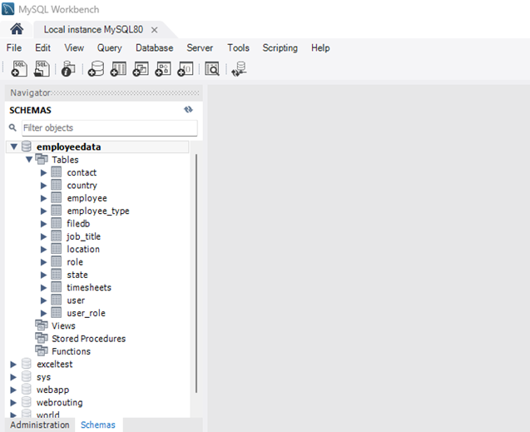  
  
  


2. After importing our project to Eclipse IDE 2022-12, navigate to the "application.properties" file and ensure that the "spring.datasource.username" is set to "root" and that the "spring.datasource.password" is updated to your Workbench password. Failure to change the password will result in an inability to create or access the database.  
  


3. Right-click on our project and select "Run As SpringBoot App" to start the project. The system will display a message indicating that the project has been created successfully.



  
4. Return to MySQL Workbench and refresh the Scheme list for the database to display.

  
  
  


5. Double-click on the "employeedata" schema in the list to make it bold, indicating that you are focusing on this database. Then select Administration. Then select Data Import/Restore.

  
  
  




6. Next Select Import from Self-Contained File, then point to where the project is stored, and select the data.SQL file, and finally make sure your Default Target Schema is set to the correct one.



Navigate to the "data.sql" file located in YourMainDict\EmployeeManagementDatabase\src\main\resources where you have the project stored  
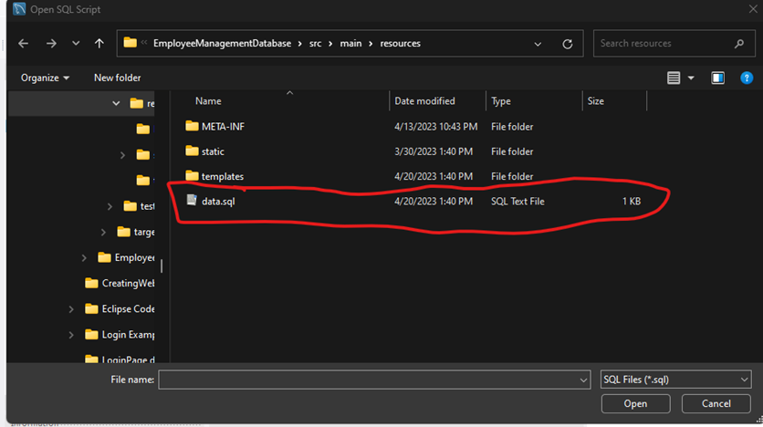

Then select Start Import



7. Once it is done running and importing data it will look like the following:  
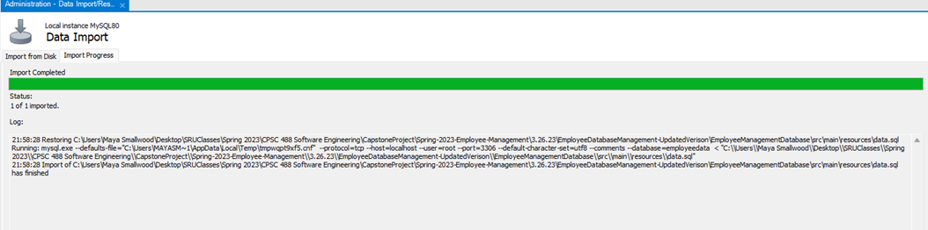

8. Next go back to Schemas and Refresh the schema list again and select the drop-down menu to display the tables.



9. To ensure that the data was entered correctly, select "user" and right-click to display its information. The table will now be populated with data from the data file and will display on the corresponding pages of our project.





Resources

**Application Properties**

**spring.jpa.hibernate.ddl-auto**=update

Used to embed a database and create a schema using the update attribute to update the connected Database every time a change is made and the program runs.

**spring.datasource.url**=jdbc:mysql://localhost:3306/demo?createDatabaseIfNotExist=true

The URL or link to access the MySQL workbench database. It is set to automatically create a schema rather than importing it from a SQL file.

**spring.datasource.username**=root

The username that is authorized to the server to be accessed.

**spring.datasource.password**=GAzebo23\!!

The password that is authorized to the server to be accessed. Will be required to be changed based upon the individual programmer’s password on that machine.

**spring.jpa.properties.hibernate.format_sql**=true

**spring.main.allow-bean-definition-overriding**=true

Both of these allows an overriding of the @Bean tag names, an error that would occur from time to time.

**spring.thymeleaf.cache**=false

**spring.thymeleaf.prefix**=classpath:templates/

Used to helped thymeleaf locate the HTML pages inside of templates, this is optional another fix is the following:

**Right click on your main project and navigate to the following:**

Build Path → Configure Build Path…  
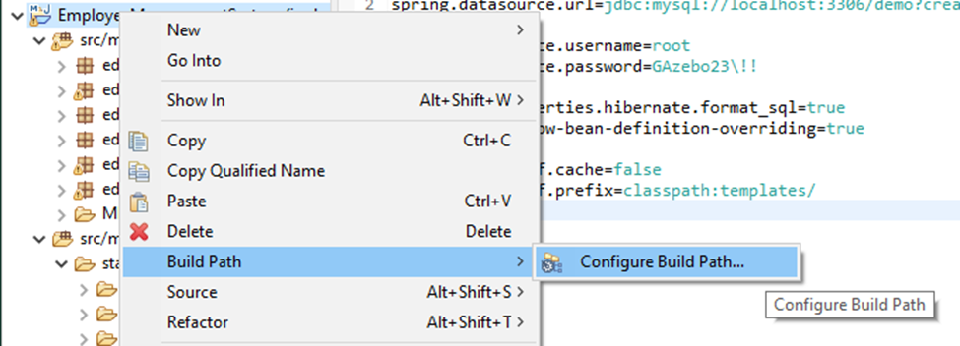 Figure 3. Thymeleaf Build Path

Tab over to Source → and then move down to “YourProject’sName/src/main/resources” → Double click “Excluded: **”  
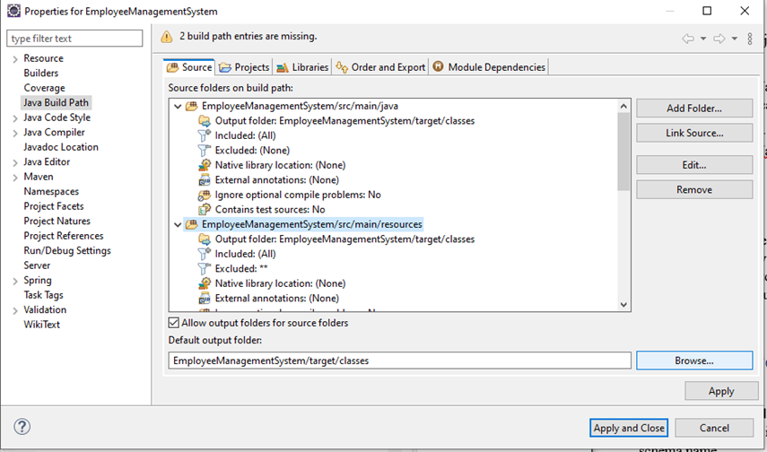Figure 4. Thymeleaf Build Path

Next select Remove in the Exclusion Patterns Area”

then select Add Multiple… in the Inclusion Patterns Area:

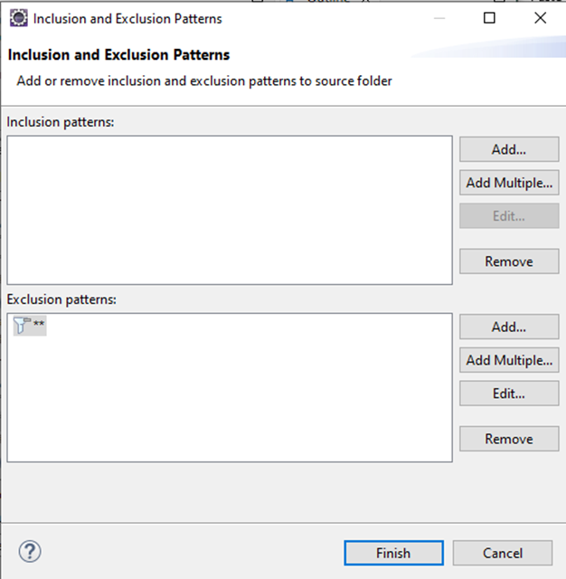Figure 5. Thymeleaf Build Path

Do a Ctrl + A to select all the following files and then select OK

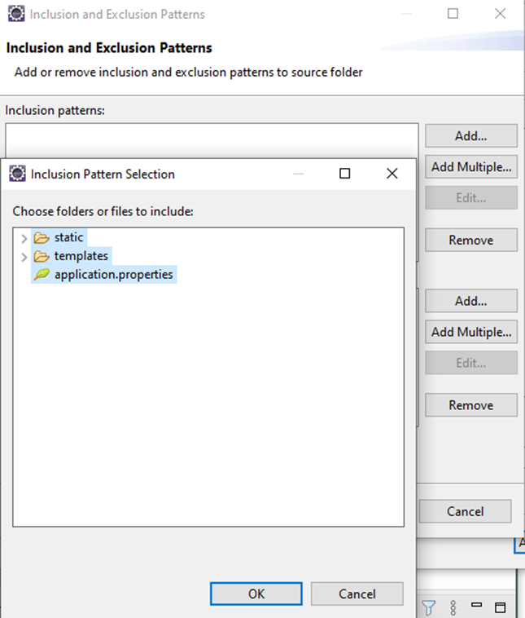  
 Figure 6. Thymeleaf Build Path

Then select Finish

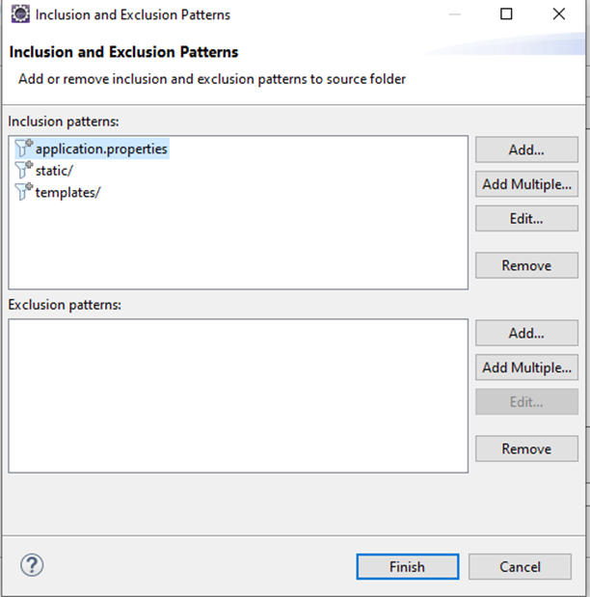 Figure 7. Thymeleaf Build Path

Select Apply and Close and then wait for your project to finish building and now Thymeleaf will stop giving errors of: *“Cannot find template location: classpath:/templates/ (please add some templates or check your Thymeleaf configuration)”* *Note: You may have to redo this progress if you close and reopen the project, or if you do a Maven→Update Project*

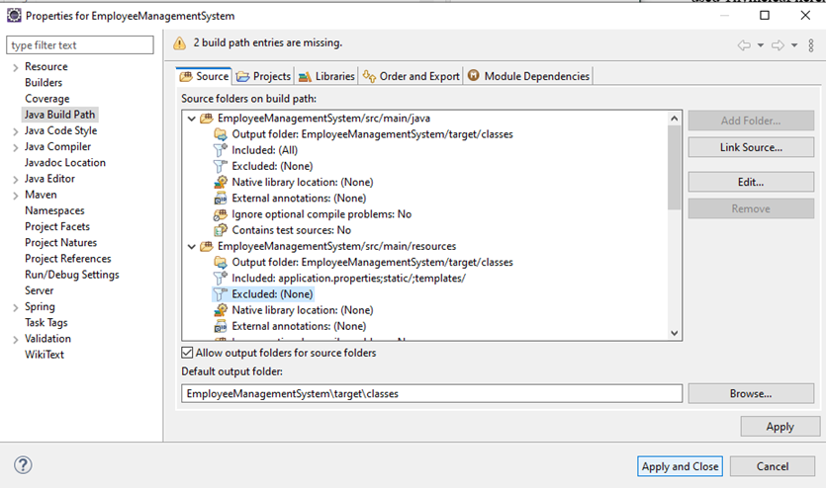

Figure 8. Thymeleaf Build Path

## 

## 

## Security Manual

**Overview**

This security manual aims to go over some of the issues that were present during the project’s development and what was done in response to those problems. Many of the issues that had arisen over the course of development were issues that were/could have been expected. This of course does not mean that they did not need to be documented or have any less time spent on resolving them. Testing proves critical prior to deployment, even when it is only a small piece of the project that has been added on to the larger whole. The following list of problems were just a few of the issues that were encountered during development. They do represent everything that may go wrong, but more so what was discovered and corrected. The issues that were discovered and corrected will be presented across the next few pages of this manual.

**Database Connectivity**

Database connectivity issues were persistent throughout the early stages of project development. The primary issue being that when the User procured a fresh copy of the project via GitHub, the project would come with a pre-integrated copy of the developer’s MySQL password. That is, the user's copy of the project would be trying to access the user’s database instance with an incorrect password. A simple app.properties password change within the project itself would work, but a long term fix was needed as this was time-consuming as well as inconvenient.

Another issue that was discovered in relation to the database was that there was a bit of trouble when importing a data.sql file into the database.

**User Redirection**

User redirection is a critical part of any web-based program. Redirections can be event based or in some cases automatic after a specific instance has occurred. It is critical to have redirects timed and mapped correctly. There were a few issues that arose throughout development in which a user may be redirected to an incorrect place or perhaps redirected to an area that they should not/were not authorized to be. Security corrections were made to ensure that Users could not be redirected to un-authorized areas. This involved corrections in validation and correction in User roles. Small changes were also made to ensure that a User was properly redirected and not just sitting idle on a page.

**MVC Issues**

There were various issues that arose during the development process from the model-view-controller standpoint. Many of the issues present were either syntax or event flow errors that simply needed to be reworked on the developers end. The “daisy-chaining” of all the elements that go into producing a finished page from back to front end could get quite confusing. Compound that with different pages utilizing different resources and the process could get complicated rather quickly.

# 

# 

# 

# **Project Completion**

## Evaluation Manual

**Table of Contents**

* Problems with the system
  + Problem 1: Passwords and their restrictions
  + Problem 2: Unused Models
  + Problem 3: Encrypting Passwords From The data.sql File
  + Problem 4: Database Connections
  + Problem 5: Automatic Import of data.sql file
  + Problem 6: Redirecting users
* Improvement/Expansion
  + Messaging System
  + File Server
  + Updating employee information
  + Work Logging
  + System Logging

**Problems and How They Can Be Fixed**

**Problem 1: Passwords and their restrictions**

At this time the program does not make the user enter their new password twice in order to check that they match. This is an important security feature to ensure the user knows their password and did not mistype, therefore locking them out of the system if they happened to do so. At this time, we also have only placed a limit on the length of passwords which must be 6-10 characters long. Restrictions requiring the password to contain capital letters, special characters, numbers, etc have not been implemented. You can find the code regarding password creation inside “LoginController.Java” and “registration.html”. Currently, registration.html holds the value “minimum length 6” and “maximum length 10” values inside of it (as seen in Figure 1).

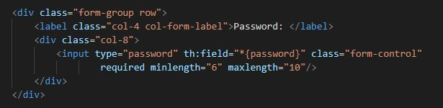

Figure 1. Limits password creation to 6-10 characters.

There may be a way to set password restrictions within the LoginController.java file by creating checks to ensure an allowed input has been entered. You can see this in Figure 2. Where we have checks in place to ensure the new password being entered is not null in the event of changing the user's password. Code similar to this may allow you to set further password restrictions.

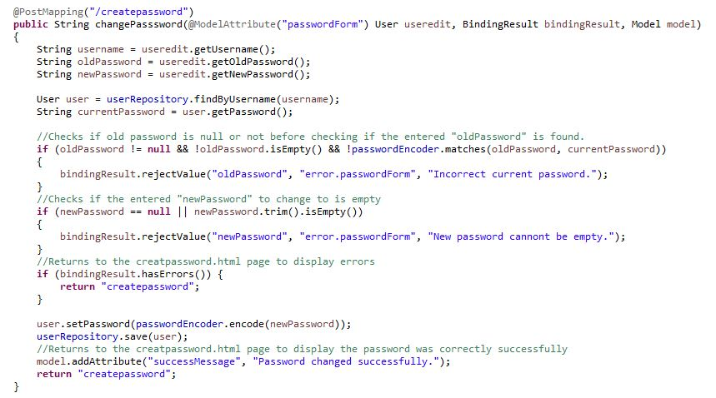

Figure 2. Code for changing password. Checks are shown to ensure the new password is not null

**Problem 2: Unused Models**

Our project currently has models that were created to aid in improving our project that were never implemented. These models can be used as a start to build upon what we already have in the project. These unused models are Auditable.java, CommonObject.java, Contact.java, Country.java, Employee.java, EmployeeType.java, JobTitle.java, Location.java, Payroll.java, Person.java, and State.java. The basic framework for these was put in place in the early stages of our project, and was not gotten to in time for final submission but should be useful in aiding any future groups.

**Problem 3: Encrypting Passwords**

Within the data.sql file, you will see that the field for the user password is left blank. This is because we could not find a solution to having the password stored as an encrypted value within the MySQL database. It is because of this that the user will have to click on “Forgot Password” upon logging in to create their password for the first time. If a solution can be found that allows an administrator to include passwords into the data.sql file and have their encrypted values saved to the database, not plain text, then it would eliminate the need for the user to set a new password before first logging into the system.

**Problem 4: Database Connections**

Within the application.properties file found in resources is the information to log in to a MySQL workbench instance using your username and password. When we merge our code to GitHub the application properties file will not merge correctly as the rest of the project does. This causes developers to enter in their MySQL password each time they import the project from GitHub, which can cause confusion and errors if not changed before running the application. We could not find a fix for this and are unsure why the application.properties file will not save changes upon merging.

**Problem 5: Automatic Import of data.sql File**

Ideally, the data.sql file found in resources should be automatically imported upon running the project using spring boot tags that can be found within “editingdatasqlfile.txt”. For an unknown reason, the spring boot tags spring.sql.init.mode=always will continuously attempt to populate the database, however, MySQL will return an error seeing that there is a duplicate entry to a specific row. The tag spring.sql.init.mode=embedded will fill the database once, but upon rerunning the application it will not automatically update, also causing errors.

**Problem 6: Redirecting Users**

Currently in the program, on the Time Sheet and Add Users webpages when importing an Excel file, users are directed to a blank success screen rather than back to the previous webpage. Once on this screen users must click “Gazebo HQ” in the top right-hand corner, go back to the dashboard, and then click back into either Time Sheet or Add User to get back to where they were. Ideally, users should be sent directly back to the page they were on, to begin with. During the spring boot initiation process of importing the Excel file is when it sends the users to the success screen, and the addition of Thymeleaf tags inside of the HTML file redirecting users back to the correct page was unhelpful in trying to solve this issue.

**Future Work**

**Messaging System:**

Originally we wanted to implement a messaging system into our system, similar to Slack, where employees could communicate from within the system to one another, and have their own inboxes, etc. Unfortunately this goal was not achievable within our time frame due to the various issues we encountered. One way to implement this feature could be to set up an SMTP server and assign email addresses to each employee, then implement the server into the project in a way that displays all incoming and outgoing messages. Our reasoning for wanting to include this is that our goal was to create a system that could be used for companies who have recently moved to remote or hybrid working conditions. Having a system where you can keep track of payroll, employee databases, and also message other employees would help keep the number of programs required to function as a business minimal.

**File Server:**

Another system we were not able to implement was a file server. Ideally, this page would allow users to import files to the server, as well as search for files that have already been imported. Once a file from the server has been selected it would show up in a panel on the screen to be viewed before the user can choose to download it onto their machine. The system we had in mind was similar to that of D2L where a professor could upload a file to be viewed within the shell, and then download it if necessary. A system like this would allow companies to store important documents within their management systems such as employee contracts, employee guidelines, company notices, and any other files that may be appropriate. This system should have permissions that can be set so that certain employees can view certain documents and not all of them. This is important so that admins or managers can view all documents but employees can only view documents that pertain to them in their specific role.

**Updating employee information:**

This was a problem we ran into toward the end of our project. Currently in the top right-hand corner of each page is an avatar icon that can be hovered over. Upon hovering, you will see two options, settings, and log out. Currently, if you click on the settings option, it will send you to our account settings page where it will display the user’s information such as their name, email address, etc. Ideally, there should be an option within this page to adjust these values, for example, a user should be able to edit their saved email address, or address. We were not able to have this function because the system could not recognize which user to update within the database table. While displaying information to the page was able to select the currently logged-in user, sending information to update the database was producing errors due to the system not knowing which user to send the information to.

**Work Logging:**

Employees while working should receive updates from the system such as reminders about timesheet information, updates to their user information, and other important tasks completed within the system. There should also be periodic banners that appear after a specified time of inactivity prompting the user to sign out of the system for security purposes.

**System Logging**

There should be a system log accessible by admins that displays any and all information happening within the system. This should be a page that displays time stamps with exact changes made to the system in a list. For example:

* 04/24/2023 11:43:56 ADMIN pms1006 created new USER bdw1006
* 04/24/2023 15:22:13 ADMIN pms1006 added file Contract.txt to FILE SERVER

This should be done so that admins can properly track system usage and easily identify any mistakes made within the system during the workday or pinpoint misuse of the system to a specific user.

# References

Project Idea and Examples of how it can be done through Spring-Boot

Fadatare, Ramesh. "Tutorial-build-employee-managment-project." Java Guides, Java Guides, 28 Feb. 2022, <https://www.javaguides.net/2021/07/spring-boot-tutorial-build-employee-management-project.html>

<https://www.youtube.com/watch?v=Buya2plwkj4&t=907s>

HTML & CSS Website Layout-Reference to how we can set up and correctly use tags and positions to label and place different website assets.

Twitter Inc. "Bootstrap." GitHub, version 5.3.0, Twitter Inc, 2022,<https://getbootstrap.com/>

Thymeleaf for security documentation

Tanzu, VMware. "Securing a Web Application" Spring. <https://spring.io/guides/gs/securing-web/>

Tanzu, VMware. "Spring Security Architecture" Spring.  
<https://spring.io/guides/topicals/spring-security-architecture/>

Spring Boot Thymeleaf documentation

The Thymeleaf Team. “Documentation-Thymeleaf 3.1”06 December 2022.   
<https://www.thymeleaf.org/documentation.html>

MySQL Workbench Joining Tables-User & Admin, and authorization

Fadatare, Ramesh. "Spring Boot Tutorial." Java Guides, Java Guides, 28 Feb. 2022,<https://www.javaguides.net/p/spring-boot-tutorial.html>

Minh Ha Nam. "Spring Boot Security Role-Based Authorization Tutorial." CodeJava, CodeJava.net, 05 March. 2023,<https://www.codejava.net/frameworks/spring-boot/spring-boot-security-role-based-authorization-tutorial>.

Color Hex Site

<https://www.color-hex.com/#>

CSS Values for Dropdown Menu

<https://www.w3schools.com/howto/howto_css_dropdown.asp>

Using Thymeleaf to display information

<https://www.thymeleaf.org/doc/articles/springmvcaccessdata.html>

Pulling data from a database and displaying on a page

<https://websparrow.org/spring/how-to-fetch-data-from-database-in-spring-mvc>

Book from class:

Object Oriented Software Engineering Using UML, Patterns, Java by Bernd Bruegge